|  |  |  |  |
| --- | --- | --- | --- |
| Skyscrapers in city  **User Guide** | | | |
|  |  |  |  |
|  | |

**COPYRIGHT**

**© 2025 Speechlogix Inc. All rights reserved.**

This document and its contents are the property of Speechlogix Inc. and are protected under international copyright laws. No part of this publication may be reproduced, distributed, or transmitted in any form or by any means, including photocopying, recording, or other electronic or mechanical methods, without the prior written permission of the publisher, except in the case of brief quotations used in reviews or scholarly works.

DGVOX and all related marks are trademarks of Speechlogix Inc. Unauthorized use is strictly prohibited.

Contents

1. Introduction to DGVox Call Recording Solution 4

1.1. Key Features 4

2. Getting Started 5

2.1. Signing In to the Application 5

2.2. Navigating the Dashboard 6

3. Station Monitoring 8

4. Call Recording Reports 9

4.1. Agent Report 9

4.2. Archive Report 10

4.3. Audit Trail 11

4.4. Call Report 12

4.4.1. How to Apply Filter 13

4.4.2. How to Tag a Call 14

4.5. Color Code Report 17

4.6. Concurrent Calls 18

4.7. Deleted Call Report 19

4.8. Extension Report 20

4.9. Frequent Call Report 21

4.10. Login Track Report 22

4.11. Time Line Report 23

5. Alert Management 24

5.1. Recording Alerts 24

5.1.1. Not Recording 24

5.1.2. Network Failure 25

5.2. System Alerts 25

5.2.1. System Shutdown 25

5.2.2. System Time Change 26

5.2.3. IP Address Change 27

5.2.4. Disk Full 27

5.2.5. Client Connection Status 28

5.3. Configuration Changes Alert 29

5.3.1. Recorder Settings Change 29

5.3.2. Data Path Change 29

5.3.3. User Account Locked 30

5.4. Call Records Deleted Alert 31

5.5. Archive Alerts 32

5.5.1. Archive Status 32

5.5.2. Archive Reminder 33

5.6. Extension Alerts 34

6. System Configuration 35

6.1. Employee Management 35

6.2. Extension Assignment 37

6.3. Organizational Hierarchy Setup 40

6.4. Recorder Configuration 41

6.4.1. Recorder Channel Index Settings 41

6.4.2. Media Proxy 42

6.4.3. CTI Plugins IP Recordings 43

6.5. Role-Based Access Control 49

6.6. System Settings & Maintenance 50

6.6.1. Registration Details 50

6.6.2. Mail Settings 52

6.6.3. Data Archive Settings 53

6.6.4. Auto-Delete Settings 55

6.7. User Management 56

6.7.1. Adding User Groups 58

7. Conclusion 58

# **1. Introduction to DGVox Call Recording Solution**

DGVox is an advanced call recording solution designed to capture and store telephone conversations across Analog, VoIP, and Digital lines. Featuring a robust web-based interface, DGVox empowers users to monitor, search, and analyze calls, while generating a variety of detailed reports and visualizations for in-depth analysis. By leveraging recording-based analytics, DGVox significantly improves customer service quality and operational efficiency.

Equipped with a sophisticated search engine and an intuitive playback interface, DGVox enables users to filter calls using multiple criteria, including time, date, call duration, direction, caller ID, dialed numbers, agent ID, and color-coded tags. A standout feature of DGVox is its fully customizable dashboard, tailored to meet individual user preferences and requirements.

DGVox is widely adopted across diverse sectors, including Call Centers, Banking, Government, Defense, Security, Utilities, Transportation, and more, addressing a broad range of call recording and compliance needs.

## **Key Features**

1. **Multi-Channel Recording** (Analog, VoIP, Digital) – Enables seamless recording across various telephony systems for complete communication coverage.
2. **Web-Based User Interface** – Provides intuitive, browser-based access for remote call monitoring, search, and analysis from any location.
3. **Advanced Search Engine** – Allows fast and efficient retrieval of call records using detailed filters to save time and enhance productivity.
4. **Customizable Dashboard** – Displays critical metrics and real-time alerts tailored to user preferences for better operational awareness.
5. **Comprehensive Reporting and Analytics** – Generates detailed reports and graphical insights to support informed decision-making and compliance tracking.
6. **Playback and Tagging** – Facilitates easy review of recorded calls with tagging and grading tools to streamline evaluation and training.
7. **Scalable** **Architecture** – Supports organizational growth with a flexible system design that adjusts to increasing demands.
8. **Integration** **with** **Leading** **PBX** **Systems** – Ensures accurate call data capture and smooth operation with existing infrastructure.
9. **Alert Management System** – Delivers proactive issue detection and resolution to maintain system reliability and regulatory compliance.
10. **Flexible Archiving** (Manual, Selective, Scheduled) – Offers versatile archiving options across multiple storage formats to meet data retention policies.
11. **Agent Quality Monitoring and Training Modules** – Enables supervisors to assess and improve agent performance through recorded call evaluations.
12. **Real-Time Call Monitoring and CRM Integration** – Provides instant access to live calls and customer data for enhanced support and faster resolution.

# **2. Getting Started**

## **Signing In to the Application**

Access the application by clicking the provided URL and entering your username and password. Be aware that exceeding three login attempts will lock your account, preventing further access. In this case, contact your administrator to unlock your account.

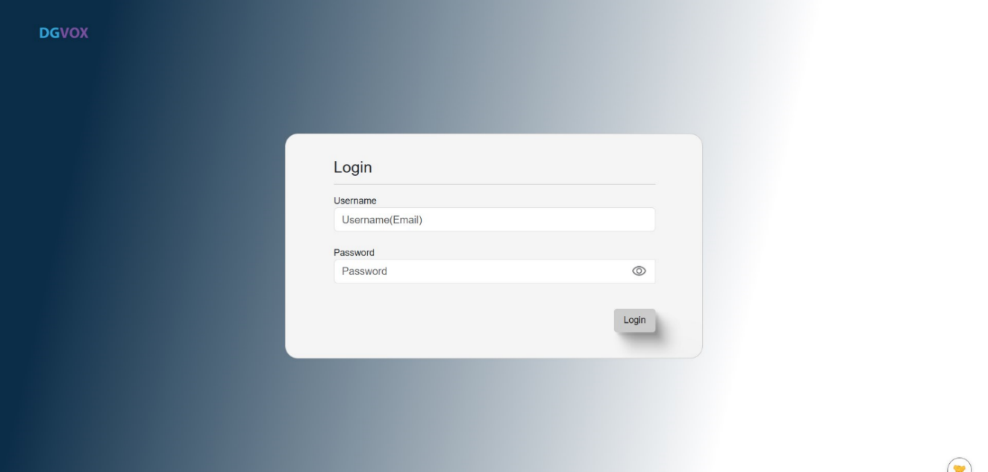

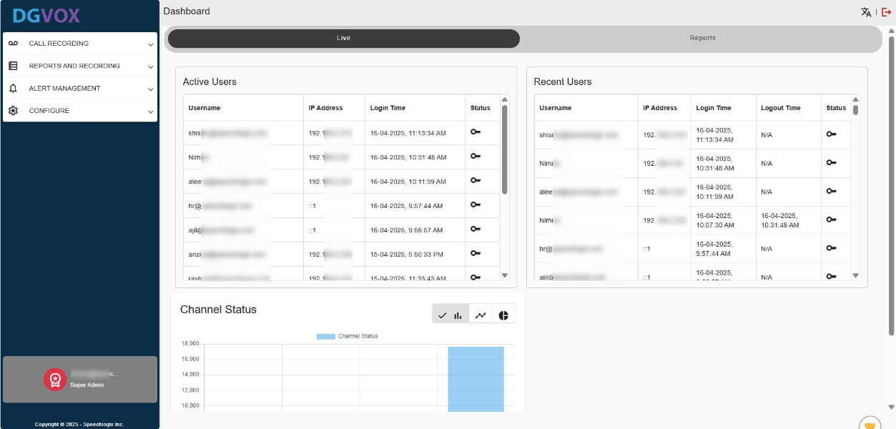The main GUI screen appears once you log into DGVOX. The user can log in with user privileges or administrator privileges. The User Interface displayed, and accessible menus differ based on the login privileges. When you log onto DGVox, **Home page** consists of a dashboard as shown below. A dashboard can be configured to display key information related to DGVOX in the form of graphical representations.

## **Navigating the Dashboard**

Navigate to **Call Recording** and then click on **‘Dashboard’** from the menu.

The dashboard provides a real-time overview of system activity and performance. It is divided into two main sections:

1. **User & Channel Overview**
2. **Live Reporting Panel**

**User & Channel Overview**

* **Active Users**: Shows the list of users currently active/online within the system.
* **Recent Users**: Displays users who have recently accessed or are currently accessing the application.
* **Channel Status**: Indicates the current state of each communication channel (Idle, On Call, Ringing, or Offline).

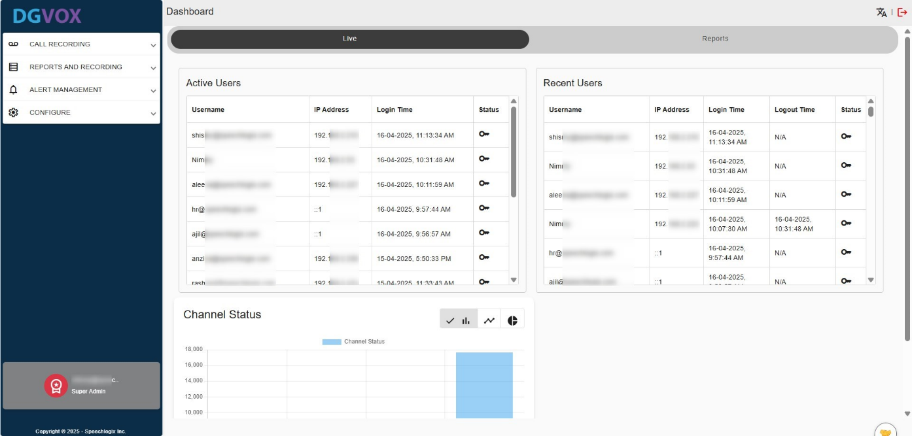

**Live Reporting Panel:** This section presents live data visualizations in various formats, including line graphs, bar charts, and pie charts. The following metrics are available:

* **Station Time Activity**: Visualizes station-wise time usage data.
* **Station Call Activity**: Displays call activity statistics for each station.
* **Frequent Calls**: Highlights the most frequently dialed or received numbers.
* **Call Type Traffic:** Breaks down call volume by type (e.g., inbound, outbound).
* **Concurrent Call Data:** Shows the number of simultaneous calls over a period.
* **Agent Time Activity**: Details how agents spend their time during shifts.
* **Agent Call Activity**: Provides insights into call handling performance per agent.
* **Daily Call Traffic**: Displays call trends and volumes on a daily basis.

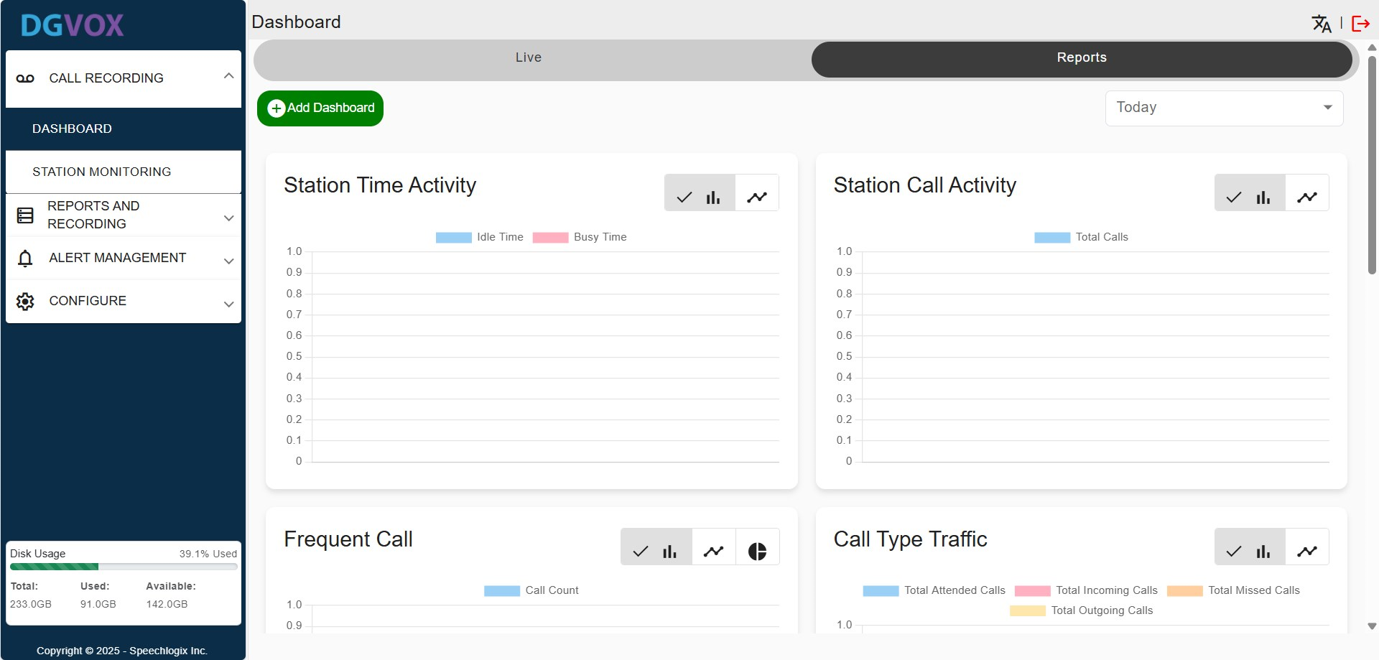

Click **‘Add Dashboard’** to select and add the widgets you want to display on your screen.

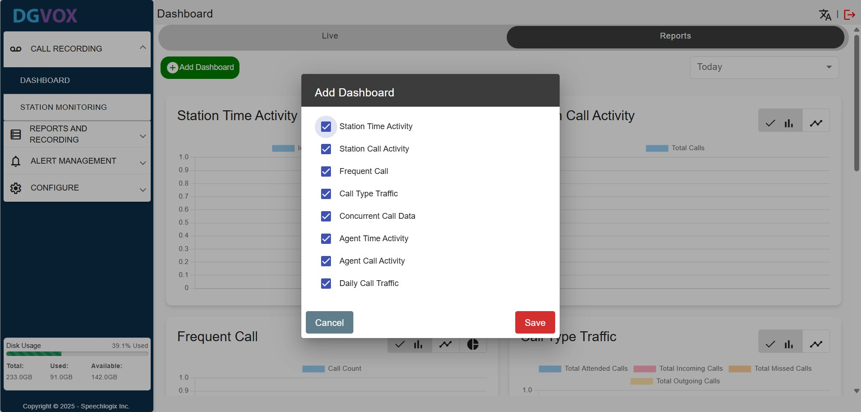

**Bottom-Left Info Panel**

* **Disk Usage**: Indicates recording server's storage status (Used vs. Available space), which is important for managing recording retention and ensuring system availability.

# **3. Station Monitoring**

It provides real-time visibility into all active and inactive extensions within the communication system. This section is primarily used by supervisors and administrators to track agent activity, channel status, and live call engagement.

The top navigation allows filtering by **Extension, Agent, Status, a** **Search bar** to quickly find specific entries.

A **‘Report’** button in the top-right corner allows exporting the current data view.

|  |  |
| --- | --- |
| **Column Name** | **Description** |
| **Extension Label** | The assigned label or name for the extension (e.g., department or user group). |
| **Extension Number** | The actual numeric identifier for the extension (used for dialing). |
| **Agent Name** | The name of the agent associated with the extension (if mapped). |
| **Agent ID** | A unique identifier assigned to the agent by the system. |
| **Caller ID** | Displays the number of the person calling in. |
| **Dialed Number** | Shows the number dialed by the agent or user. |
| **Active** | Indicates whether the extension is currently active or inactive (toggle button). |
| **Status** | Displays the current state of the extension such as:  **IDLE:** Not currently in a call  **ON CALL:** Engaged in a conversation  **RINGING:** Ringing but not yet answered  **OFFLINE:** Extension is not connected or unavailable |
| **Live Call** | Indicates if a live call is in progress and may allow for live monitoring or barge-in (depending on access level). |

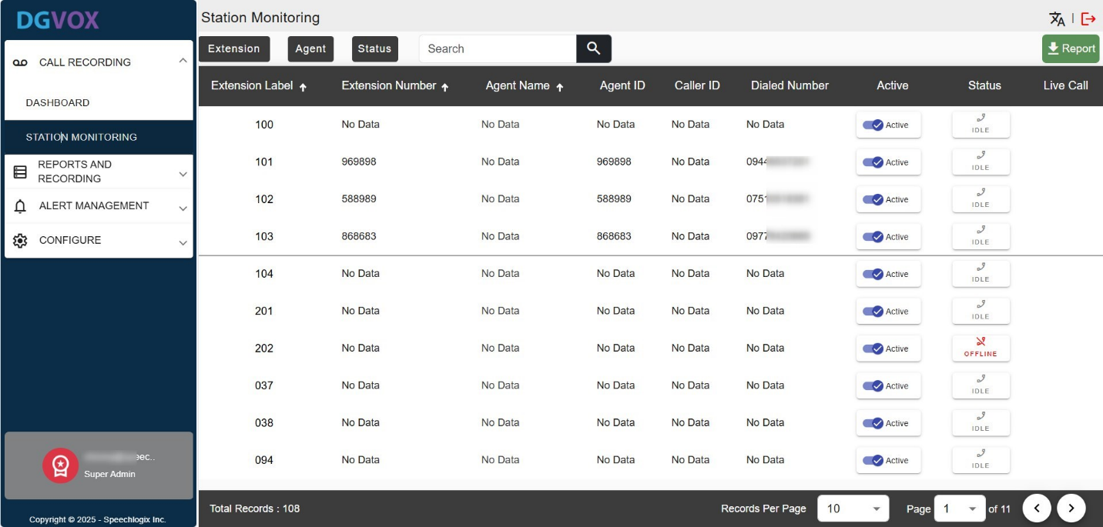

# **4. Call Recording Reports**

This section allows you to generate a call records report based on selected criteria. It provides you with a number of criteria to select from before generating a report. You can generate the reports in different formats, such as **Excel** and **PDF**.

## **4.1. Agent Report**

The **Agent Report** a summarized view of agent call activity and performance metrics. It helps supervisors and admins track key statistics like the number of calls handled, call durations, and agent workdays.

Go to **Reports and Recording** and select **‘Agents’**. Filters at the top allow report generation based on: **Time Period** (e.g., This Quarter), **Agent ID, Agent Name, Call Direction** (Inbound/Outbound).

A **‘Report’** button at the top-right allows exporting the current data view.

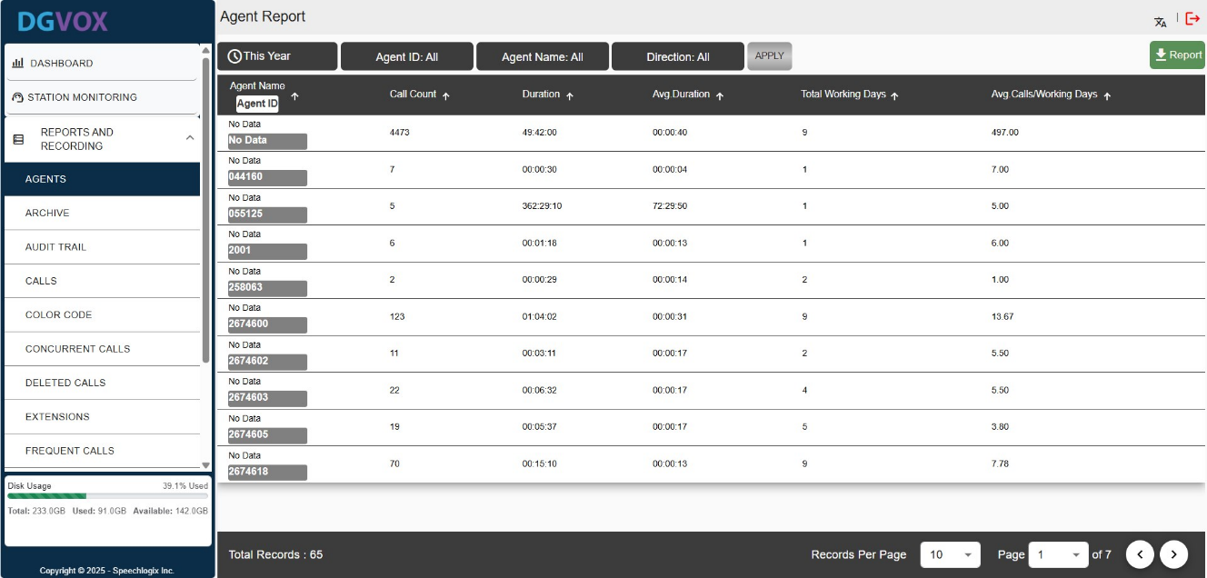

|  |  |
| --- | --- |
| **Column Name** | **Description** |
| **Agent Name** | Displays the name of the agent. If no name is linked, it shows “No Data.” |
| **Agent ID** | A unique identifier assigned to each agent within the system. |
| **Call Count** | Total number of calls handled by the agent within the selected time period. |
| **Duration** | Cumulative duration of all calls made or received by the agent. |
| **Avg. Duration** | The average duration per call, calculated as total call time divided by number of calls. |
| **Total Working Days** | Number of days the agent was active or logged into the system. |
| **Avg. Calls / Working Days** | The average number of calls handled per day, indicating agent productivity. |

## 4.2. Archive Report

The **archive report** menu or log provides information about archived data, including details about the files that have been stored or backed up for future reference or retrieval. It helps to track the status and history of data backups or archived records, ensuring that important information is preserved and can be retrieved when needed. It is used in systems for managing large volumes of data.

Go to **Reports and Recording** and select **‘Archive’**.

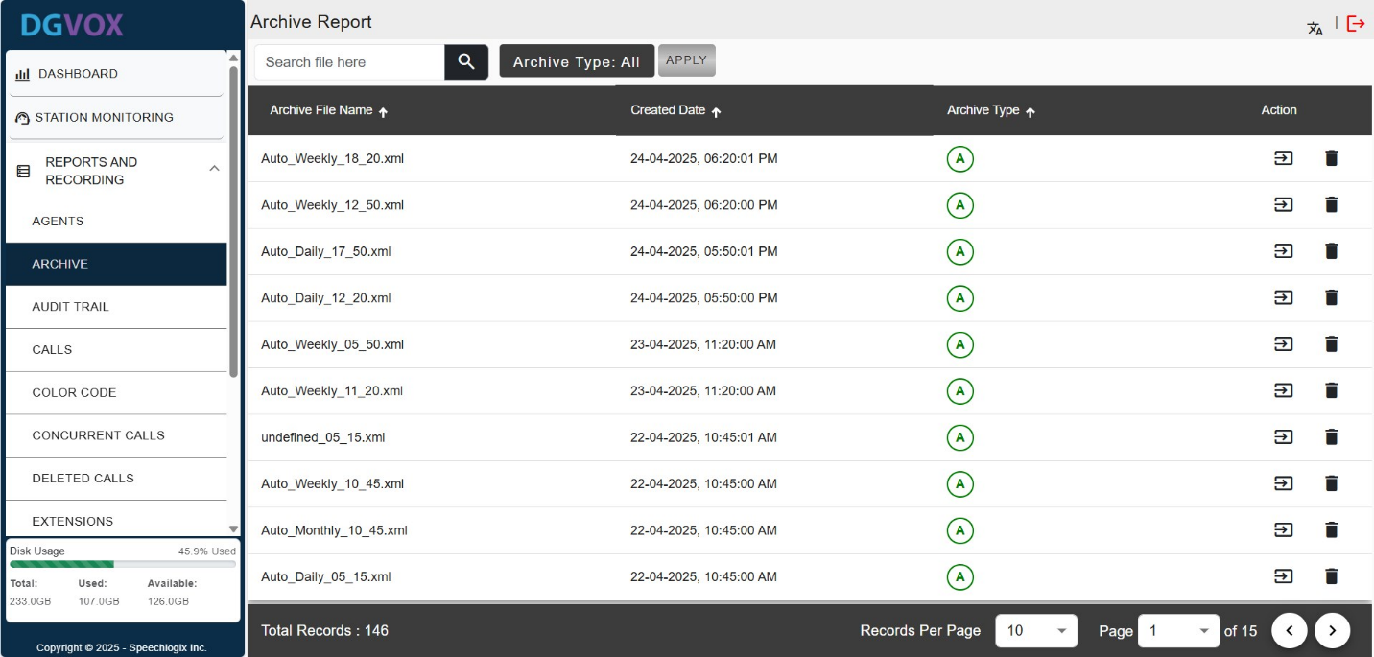The top filter bar allows filtering the Archive report by: Archive Type (Manually, Auto Daily, Auto Weekly and Auto Monthly)

## 4.3. Audit Trail

The **Audit Trail Report** provides a detailed log of all user activities. This is essential for tracking user behavior, monitoring access to sensitive modules, and ensuring compliance with operational and security policies.

Go to **Reports and Recording** and select **‘Audit Trail**.

The top filter bar allows filtering the audit trail by: **Date** (e.g., Today), **Action type** (Read, Write, Delete), **Module** (Station Monitoring, Call Recording, etc.), **User Name**

A **‘Report’** button at the top-right enables export/download of the filtered activity logs.

|  |  |
| --- | --- |
| **Column** | **Description** |
| **User Name** | Displays the email ID or name of the user who performed the action. Helps identify who accessed or modified a module. |
| **Module** | Indicates the section/module of the application the user interacted with (e.g., Station Monitoring, Call Recording). |
| **Description** | A brief summary of the activity performed by the user (e.g., “Station monitoring accessed”). |
| **Date** | Shows the exact date and timestamp (in DD-MM-YYYY HH:MM:SS format) when the action was carried out. |
| **Action** | Specifies the type of action taken: **READ** (viewed), **WRITE** (modified), or **DELETE** (removed data). |

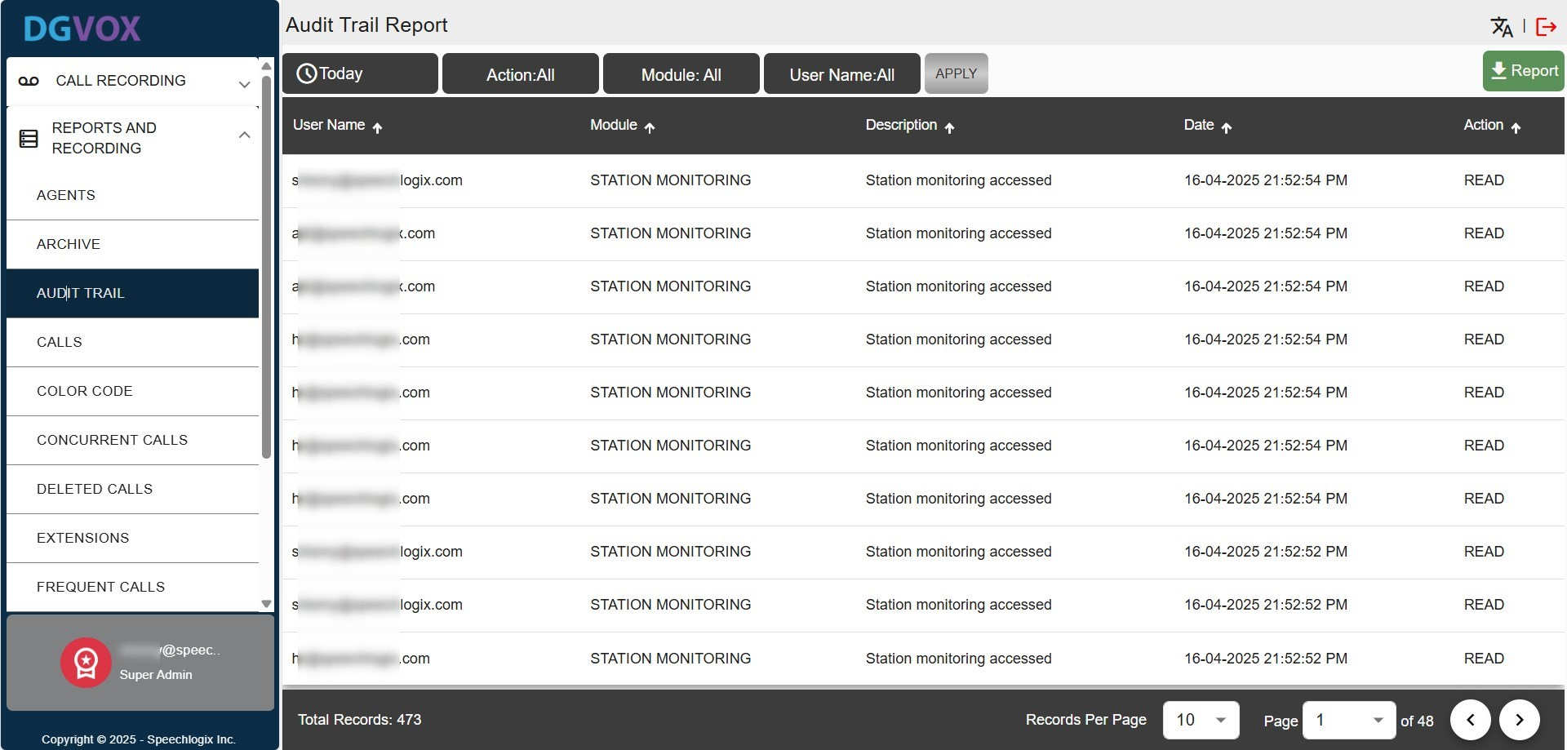

## **4.4. Call Report**

The **Call Report** menu under the **Call Recording** section provides a detailed summary of all recorded calls, including call metadata like time, duration, direction, and caller information. This is vital for supervisors, quality analysts, and compliance officers to monitor and review communication activities.

Users can filter call logs using: **Time filter** (e.g., "This Year").

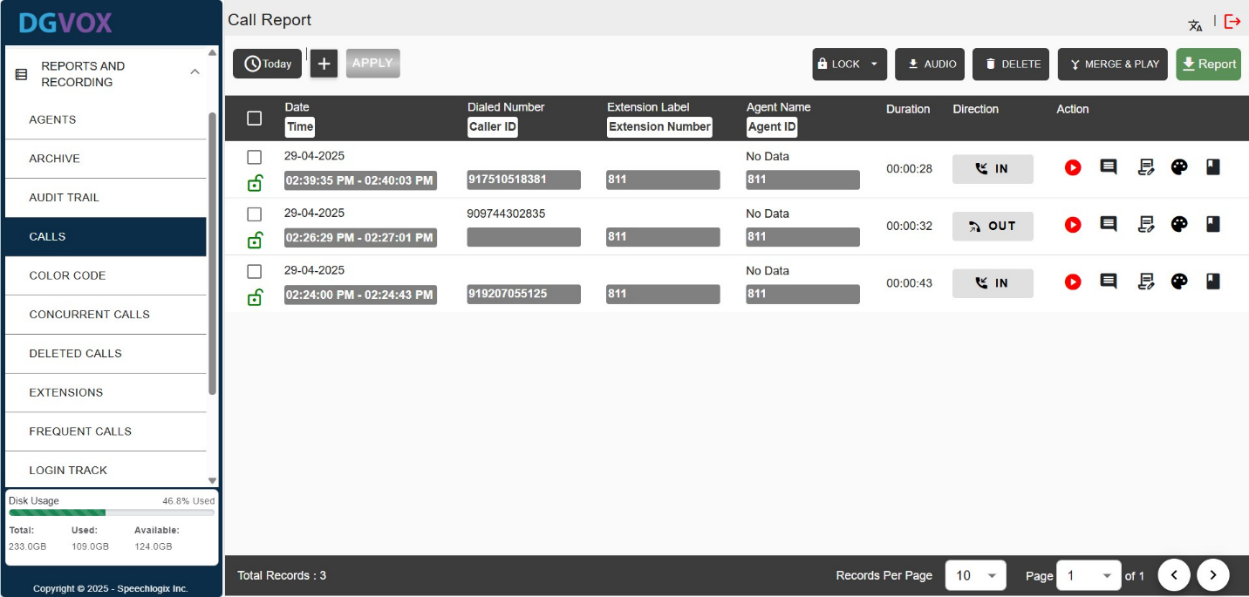

There are also action buttons for:

* 🔒 **Lock**: Secure the call record
* 🎧 **Audio**: Export/download audio files
* 🗑️ **Delete**: Remove the selected records
* 🔗 **Merge & Play**: Combine multiple recordings and play
* 📄 **Report**: Export call report in document format

A **‘Report’** button at the top-right enables export/download of the filtered activity logs.

|  |  |
| --- | --- |
| **Column** | **Description** |
| **Date** / **Time** | Shows the date and time range of the call. It’s split into start and end timestamps. |
| **Dialed Number** / **Caller ID** | Displays the number that was dialed (for outgoing) or the caller's number (for incoming). |
| **Extension Label** / **Extension Number** | Indicates the internal extension number involved in the call (e.g., 811). |
| **Agent Name** / **Agent ID** | Shows the agent's identifier who handled the call. If unavailable, it displays "No Data". |
| **Duration** | Total length of the call in HH:MM:SS format. |
| **Direction** | Specifies whether the call was **IN** (incoming) or **OUT** (outgoing), with relevant icons. |
| **Action** | Action buttons for managing call records:  ▶️ **Play** the recording  🗒️ **Notes/Comments**  🎨 **Color code/tag** the call  🗑️ **Add Call Tag** |

### **4.4.1. How to Apply Filter**

* Click the **"+"** button to open the filter panel.
* 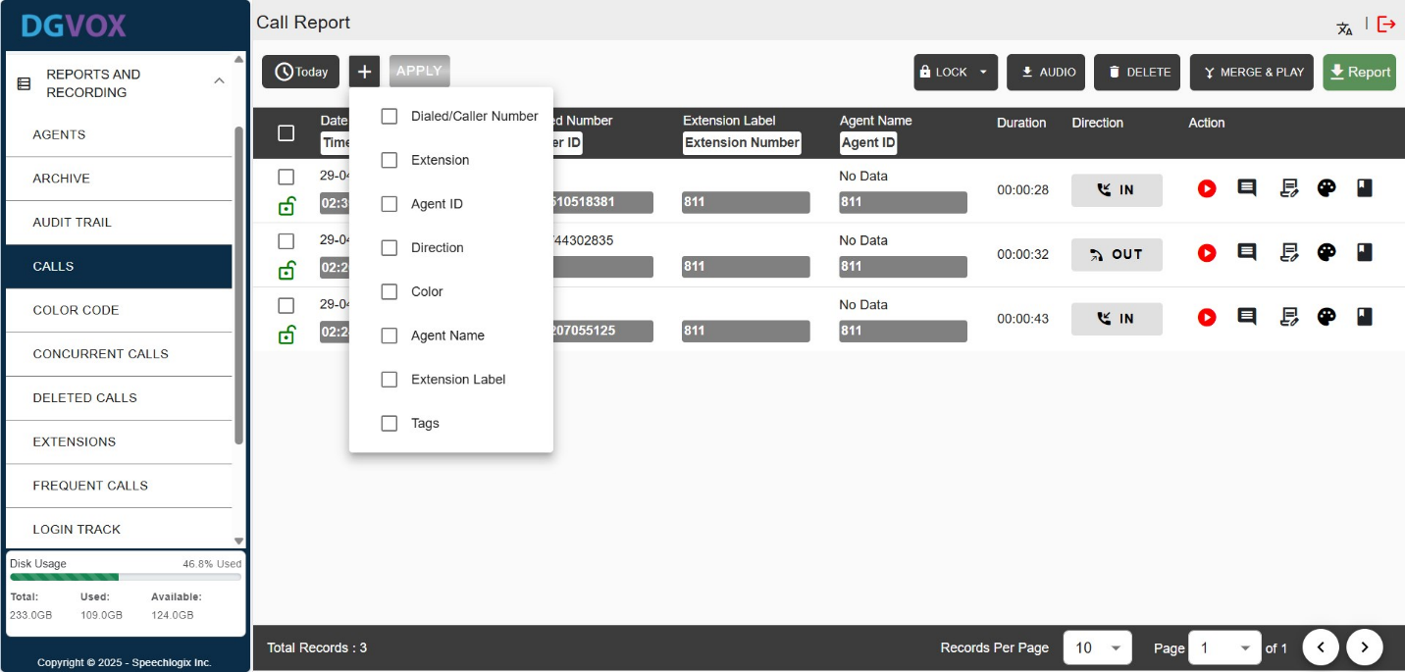Choose the fields you wish to apply filters on.
* 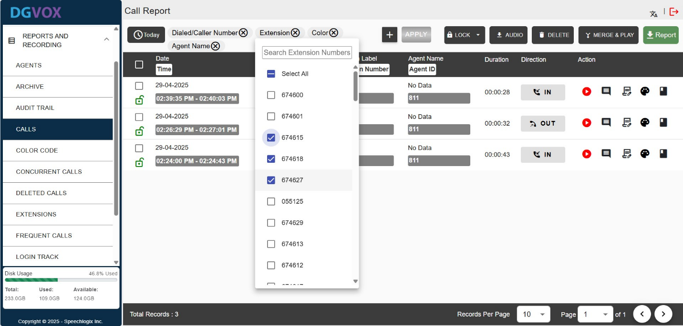After that, pick the specific values such as agent name, color, extension, etc., and press **“APPLY”** to refresh the table with the filtered results.

This filtering system allows administrators and supervisors to tailor the call report view to focus on specific information for analysis, auditing, or monitoring.

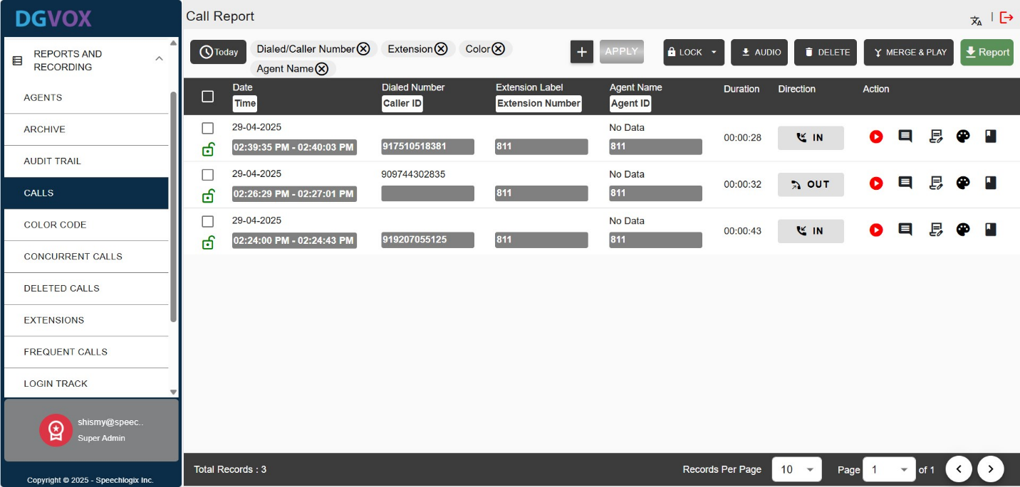

### **4.4.2. How to Tag a Call**

**Call Tagging** is a feature within the **Call Report** section of the DGVOX interface that allows users to annotate specific segments of a call recording for quick reference, analysis, or categorization.

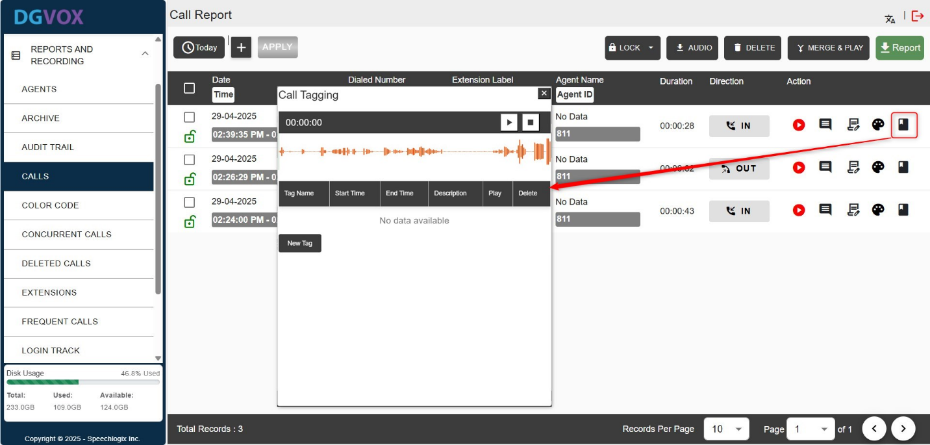From the **Call Report** page, locate the call entry for which you want to tag. Click the **tag icon** (label icon) in the **Action** column. This opens the **Call Tagging panel**.

**Audio Player and Waveform Display** (Top): Users can play back the call and visually locate the part they want to tag.

* Playback controls (play, pause) help in identifying the exact start and end points for the tag.

Click **“New Tag”** to create a tag for a specific portion of the call.

* **Tag Name:** Enter or select a label or title for the tag (e.g., "Rude", "Escalation", "Compliance").
* **Start Point & End Point:** Enter the timestamps or use playback controls to mark the desired segment. A **"Mark Start Point"** button assists in automatically capturing the timestamp from the current audio position.
* **Description:** Optional field to add more context or details about the tagged segment (e.g., what was said, why it was flagged).
* **Cancel Button:** Discards the tag creation process and closes the panel.

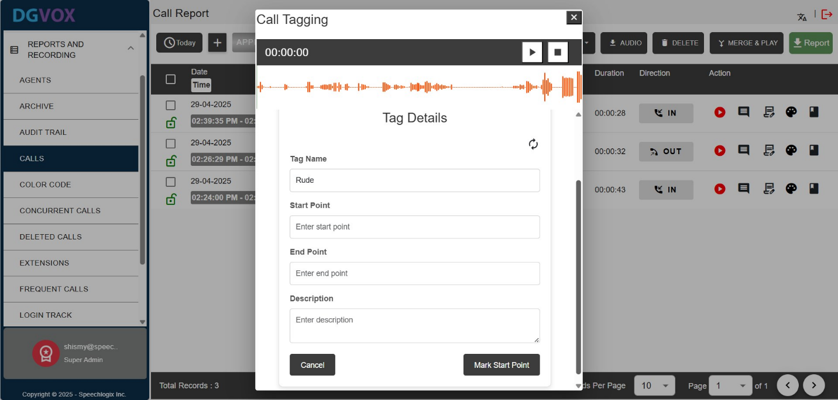

Once you tag the audio, the screen displays a **summary of all tags** applied to a selected call recording.

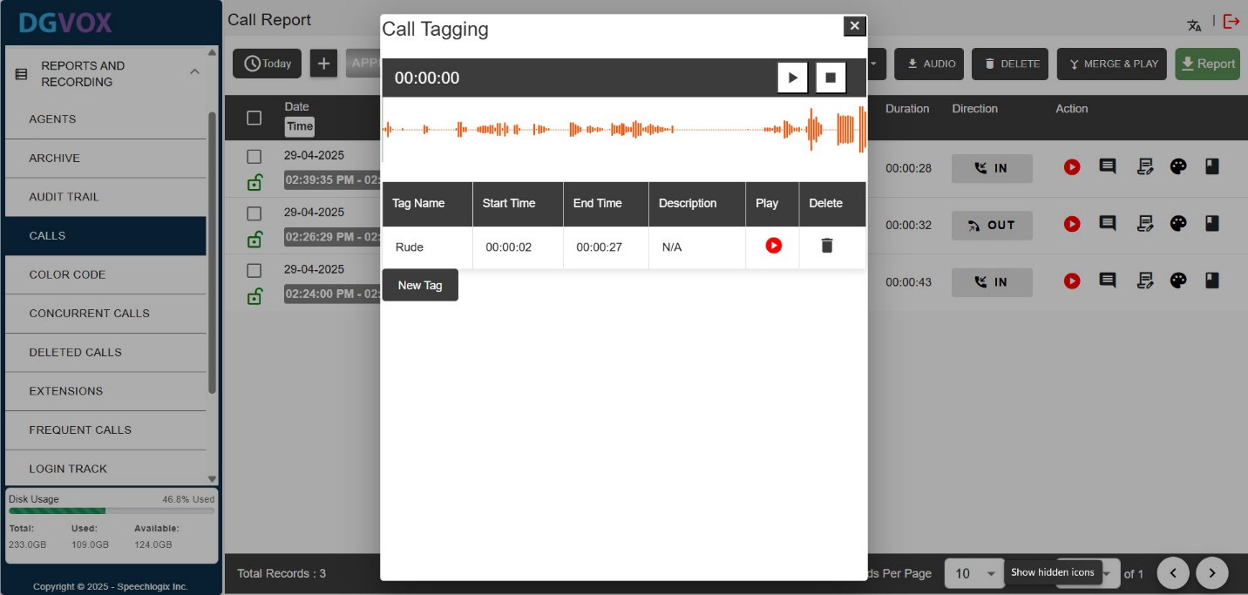

## **4.5. Color Code Report**

The **Color Code Report** under the **Reports and Recording** section provides a detailed overview of call recordings categorized by color codes within the system. This is essential for analyzing call distribution, identifying trends, and managing recording usage effectively.  
The top filter bar allows filtering the report by: **Time Period**, **Color Code** and **Direction**.  
A **‘Report’** button at the top-right enables export/download of the filtered activity logs.

|  |  |
| --- | --- |
| **Column** | **Description** |
| **Color** | Displays the color code (e.g., Black, Blue, Brown) assigned to each call recording category. |
| **Recordings** | Shows the total number of recordings associated with each color code. |
| **Percentage** | Indicates the percentage of total recordings that each color code represents. |
| **Export** | Provides an option to download the data for each color code in XLS format. |

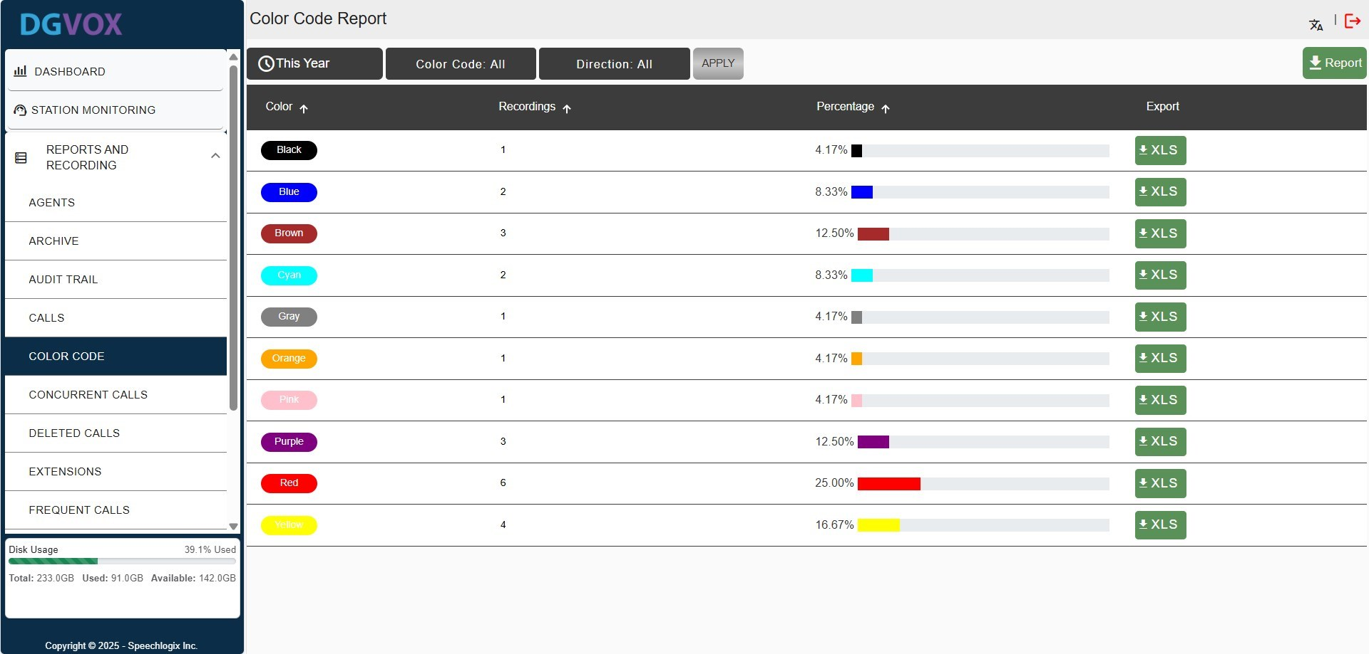

## **4.6. Concurrent Calls**

The Concurrent Report under the Reports and Recording section provides a detailed overview of the maximum number of concurrent calls handled within the DGVOX system. This is essential for assessing call capacity, identifying peak usage times, and optimizing system performance.  
The top filter bar allows filtering the report by: Time Period (e.g., Today) and Hour.  
A ‘**Report’** button at the top-right enables export/download of the filtered data.

|  |  |
| --- | --- |
| **Column** | **Description** |
| **Hour** | Displays the specific hour of the day when the concurrent call data was recorded (e.g., 01 PM - 02 PM). |
| **Maximum Concurrent Calls** | Shows the highest number of concurrent calls recorded during the specified hour. |
| **Peak Time** | Indicates the exact time within the hour when the maximum concurrent calls occurred. |

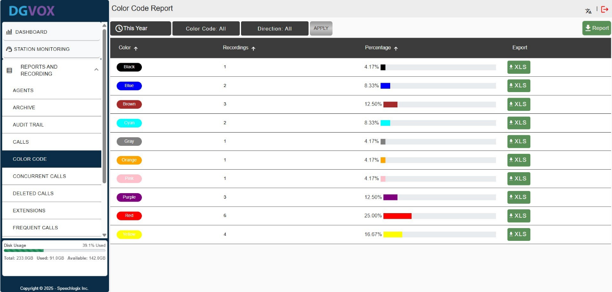

**Hour**

## **4.7. Deleted Call Report**

The Deleted Call Report under the Reports and Recording section provides a detailed log of all deleted calls within the DGVOX system. This is essential for tracking call deletions, ensuring data integrity, and auditing user actions.  
The top filter bar allows filtering the report by: Time Period, Extension, Dialed/Caller Number, and Deleted By.  
A ‘**Report’** button at the top-right enables export/download of the filtered data.

|  |  |
| --- | --- |
| **Column** | **Description** |
| **Extension Number** | Displays the extension number associated with the deleted call. |
| **Dialed Caller ID** | Shows the caller ID of the dialed or received call. |
| **Call Start Time** | Indicates the start time of the deleted call. |
| **Duration** | Reflects the length of the deleted call in hours, minutes, and seconds. |
| **Notes** | Provides any additional notes or comments related to the deleted call. |
| **Deleted By** | Identifies the user who deleted the call, marked with an icon. |

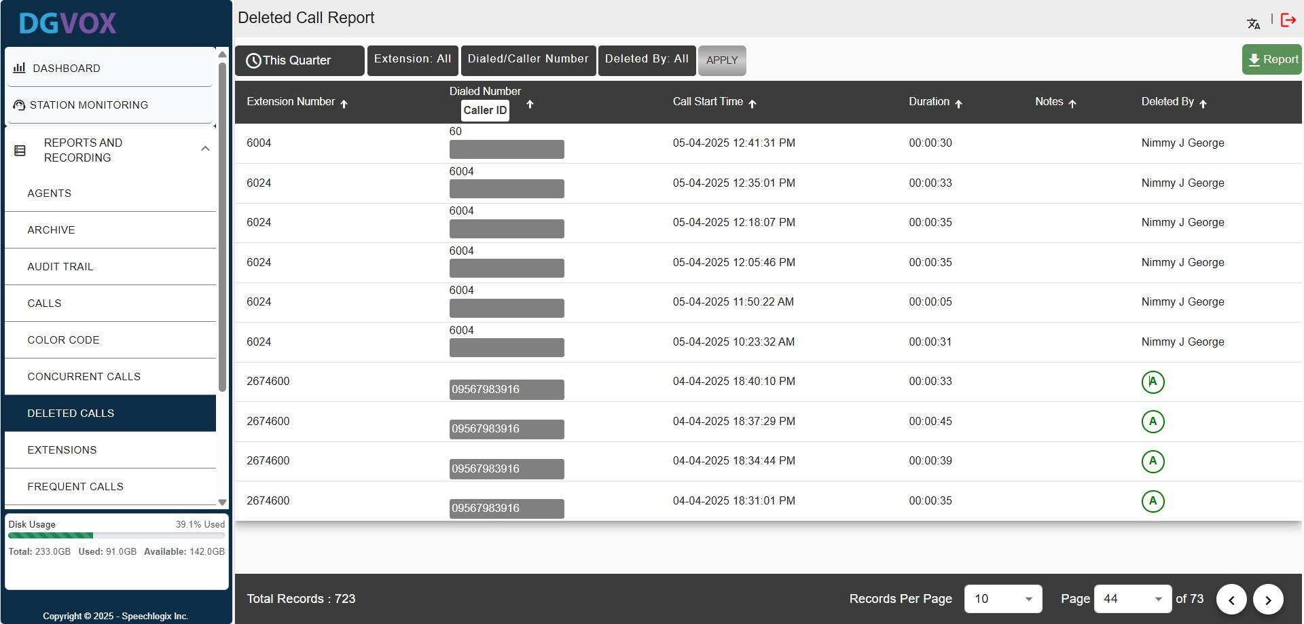

## **4.8. Extension Report**

The Extension Report under the Reports and Recording section provides a detailed summary of call activities associated with specific extensions within the DGVOX system. This is essential for monitoring extension usage, analyzing call patterns, and optimizing resource allocation.  
The top filter bar allows filtering the report by: Time Period, Extension, and Direction.  
A ‘**Report’** button at the top-right enables export/download of the filtered data.

|  |  |
| --- | --- |
| **Column** | **Description** |
| **Extension** | Displays the unique extension number associated with the call activity. |
| **Call Count** | Shows the total number of incoming calls for the extension. |
| **Incoming** | Indicates the number of incoming calls received by the extension. |
| **Outgoing** | Reflects the number of outgoing calls made from the extension. |
| **Duration(hr)** | Provides the total duration of calls in hours. |
| **Avg. Duration** | Displays the average call duration in hours and minutes. |
| **Total Working Days** | Indicates the total number of days the extension was active. |
| **Avg. Calls per Day** | Shows the average number of calls per day for the extension. |

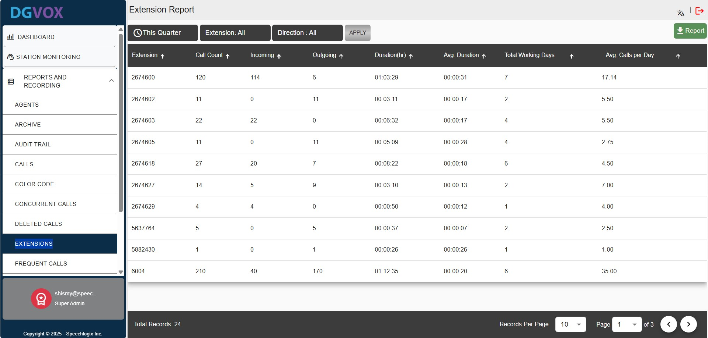

## **4.9. Frequent Call Report**

The Frequent Call Report under the Reports and Recording section provides a detailed overview of the most frequent call activities. This is essential for identifying patterns, monitoring high-usage agents, and optimizing call management.

The top filter bar allows filtering the report by: Time Period (e.g., Today), Extension, Direction, Caller ID, and Enter Phone Number.  
A ‘**Report’** button at the top-right enables export/download of the filtered data.

|  |  |
| --- | --- |
| **Column** | **Description** |
| **Agent Name** | Displays the name of the agent associated with the call activity. |
| **Extension Number** | Shows the extension number linked to the agent. |
| **Caller ID** | Indicates the caller identification number. |
| **Attended Calls** | Reflects the number of calls attended by the agent. |
| **Missed Calls** | Shows the number of calls missed by the agent. |
|  | **0-5 Secs**: Indicates the number of calls lasting between 0 and 5 seconds.  **6-60 Secs**: Displays the number of calls lasting between 6 and 60 seconds.  **1-3 Mins**: Shows the number of calls lasting between 1 and 3 minutes.  **3+ Mins**: Reflects the number of calls lasting more than 3 minutes. |
| **In/Out** | Indicates the direction of the calls (incoming or outgoing) with corresponding counts. |

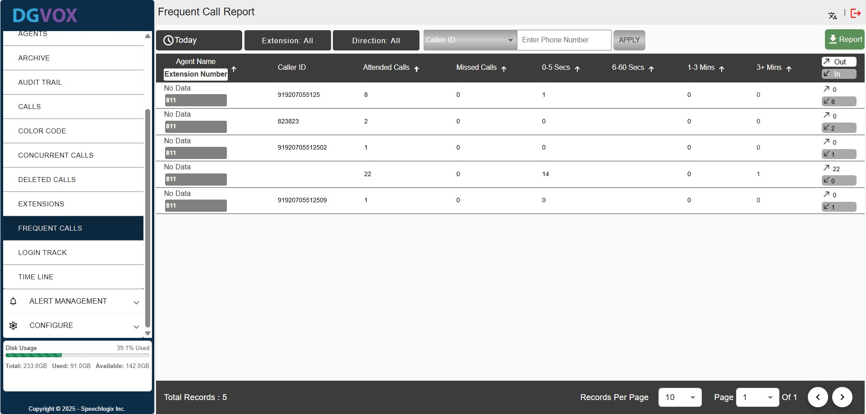

## **4.10. Login Track Report**

The Login Track Report under the Audit Trail section provides a detailed log of user login and logout activities within the DGVOX system. This is essential for monitoring user access, ensuring security, and tracking session durations.

The top filter bar allows filtering the report by: Time Period (e.g., Today), Status, and User Name.  
A ‘**Report**’ button at the top-right enables export/download of the filtered data.

|  |  |
| --- | --- |
| **Column** | **Description** |
| **User Name** | Displays the username or email address of the individual who logged in. |
| **Login Status** | Indicates the status of the login attempt (e.g., Authenticated). |
| **Login Time** | Shows the date and time when the user logged in. |
| **Logout Time** | Reflects the date and time when the user logged out. |
| **IP Address** | Displays the IP address from which the login occurred. |

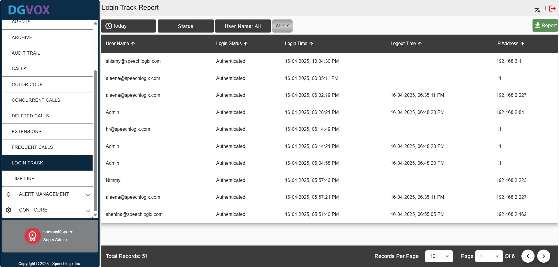

## **4.11. Time Line Report**

The Timeline Report under the Reports and Recording section provides a detailed overview of call activities distributed across specific time intervals within the DGVOX system. This is essential for analyzing call patterns, peak usage times, and optimizing call handling.

The top filter bar allows filtering the report by: Time Period (e.g., Today), Extension, Agent, and Hourly.  
A ‘**Report’** button at the top-right enables export/download of the filtered data.

|  |  |
| --- | --- |
| **Column** | **Description** |
| **Hour** | Displays the specific hour of the day when the call data was recorded (e.g., 06:07). |
| **Call Count** | Shows the total number of calls recorded during the specified hour. |
| **Duration** | Indicates the total duration of calls in hours during the specified hour. |
| **Average Duration** | Reflects the average duration of calls in hours and minutes for the specified hour. |

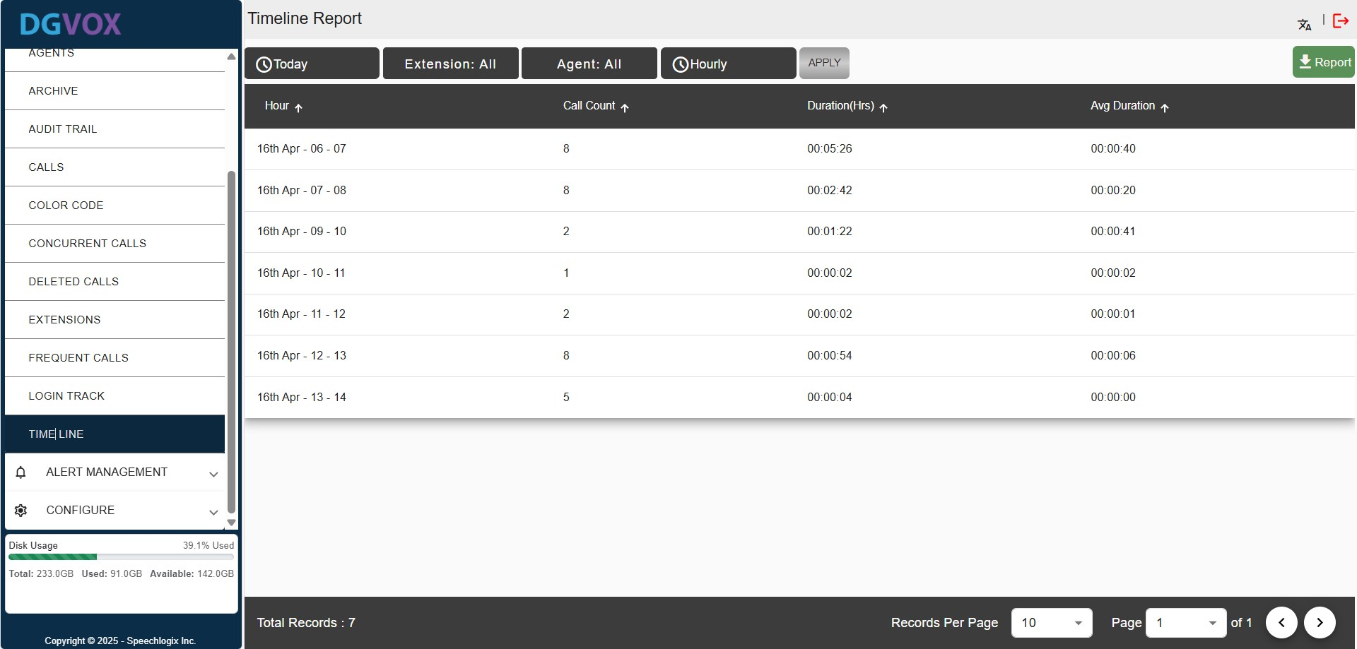

# **5. Alert Management**

Alert Management feature allows user to specify the events for which notifications or alerts need to be sent to the user for different criticality levels. The alerts can be sent via Email, SMS or as a popup. The email id and phone number will be collected from the details mentioned under User Profile. User can also enable acknowledgement feature for the delivered messages.

## **5.1. Recording Alerts**

Navigate to **Alert Management** and choose the **Recording** option. These alerts notify users about issues related to call recording functionality. They help ensure the system is capturing calls as expected.

### **5.1.1. Not Recording**

Triggered when no channels/extensions are actively recording. This could indicate a malfunction or misconfiguration. Subscribed users receive an alert to investigate immediately.

Navigate to **Alert Management**, select **Recording**, and then open the **Not Recording** tab.

Now, start by selecting the type of recorder you want to set up alerts for. After that, specify the start time from which the system should begin monitoring for any recording inactivity. Then, define the interval in minutes to determine how frequently the system should check if recording is taking place.

Next, click on the ‘**Set** **Users’** button and select the users you want to include in the list. You can also use the dropdown menu to choose specific roles and verify if those users have the necessary permissions. Finally, to activate email alerts and notifications, make sure to check the corresponding box next to each user.

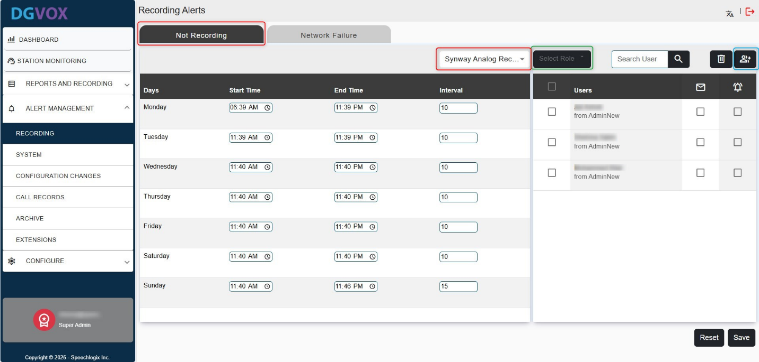

### **5.1.2. Network Failure**

Alerts are sent when the network cable is unplugged or there's a loss of connectivity in the DGVOX system. This could impact recording operations, so users are alerted to resolve the issue promptly.

Navigate to **Alert Management**, select **Recording**, and then open the **Network Failure** tab.

Next, click on the ‘**Set** **Users’** button and select the users you want to include in the list. You can also use the dropdown menu to choose specific roles and verify if those users have the necessary permissions. Finally, to activate email alerts and notifications, make sure to check the corresponding box next to each user.

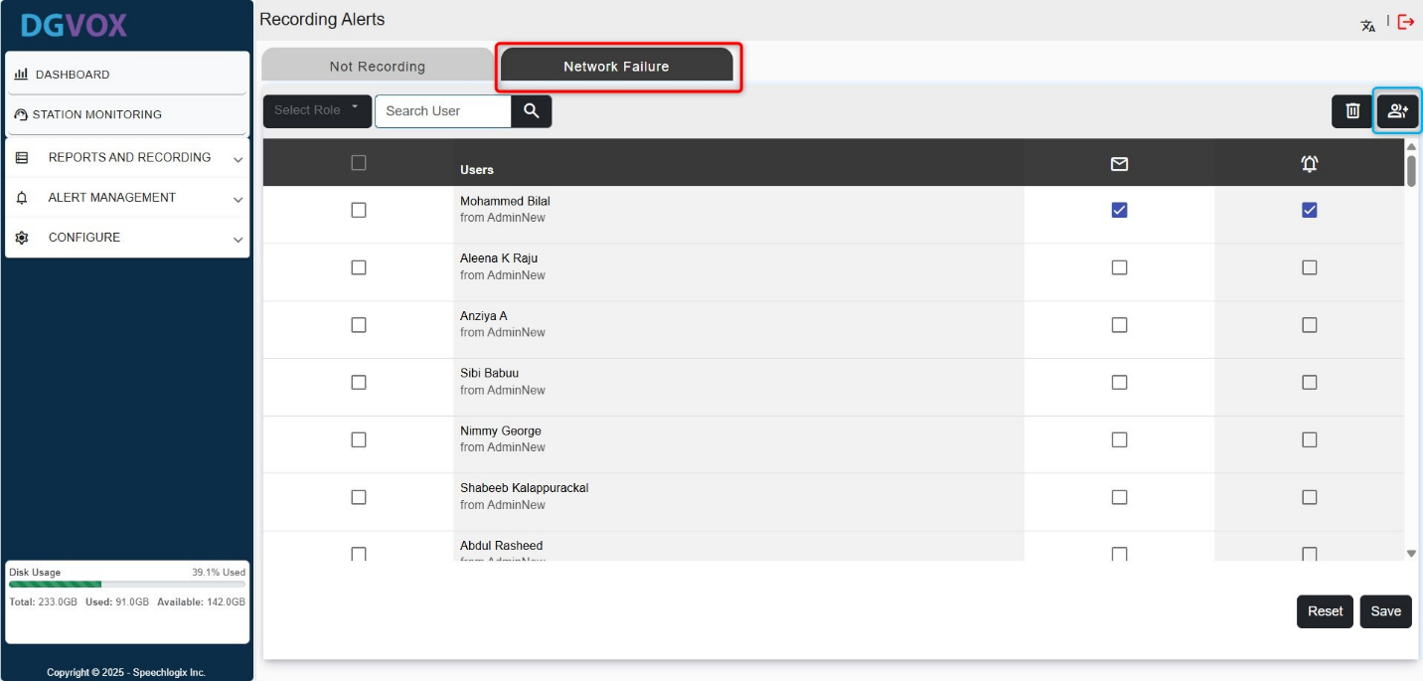

## **5.2. System Alerts**

Navigate to **Alert Management** and choose the **System** option. These alerts relate to the overall system status and behaviour, helping administrators monitor critical changes and potential issues in the DGVOX system.

### **5.2.1. System Shutdown**

Notifies users when the DGVOX system is powered off. This ensures users are aware of intentional or unexpected shutdowns.

Navigate to **Alert Management**, select **System**, and then open the **System Shutdown** tab.

Next, click on the ‘**Set** **Users’** button and select the users you want to include in the list. You can also use the dropdown menu to choose specific roles and verify if those users have the necessary permissions. Finally, to activate email alerts and notifications, make sure to check the 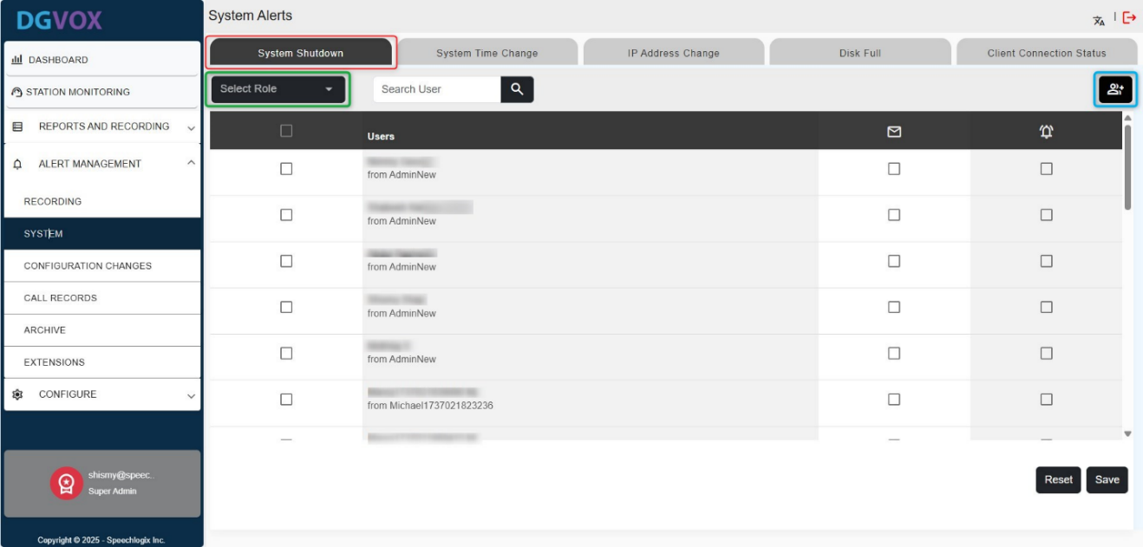corresponding box next to each user.

### **5.2.2. System Time Change**

Alerts users if the system time is manually changed. Since accurate timestamps are crucial for logging and recordings, this is an important event to track.

Navigate to **Alert Management**, select **System**, and then open the **System Time Change** tab.

Next, click on the ‘**Set** **Users’** button and select the users you want to include in the list. You can also use the dropdown menu to choose specific roles and verify if those users have the necessary permissions. Finally, to activate email alerts and notifications, make sure to check the corresponding box next to each user.

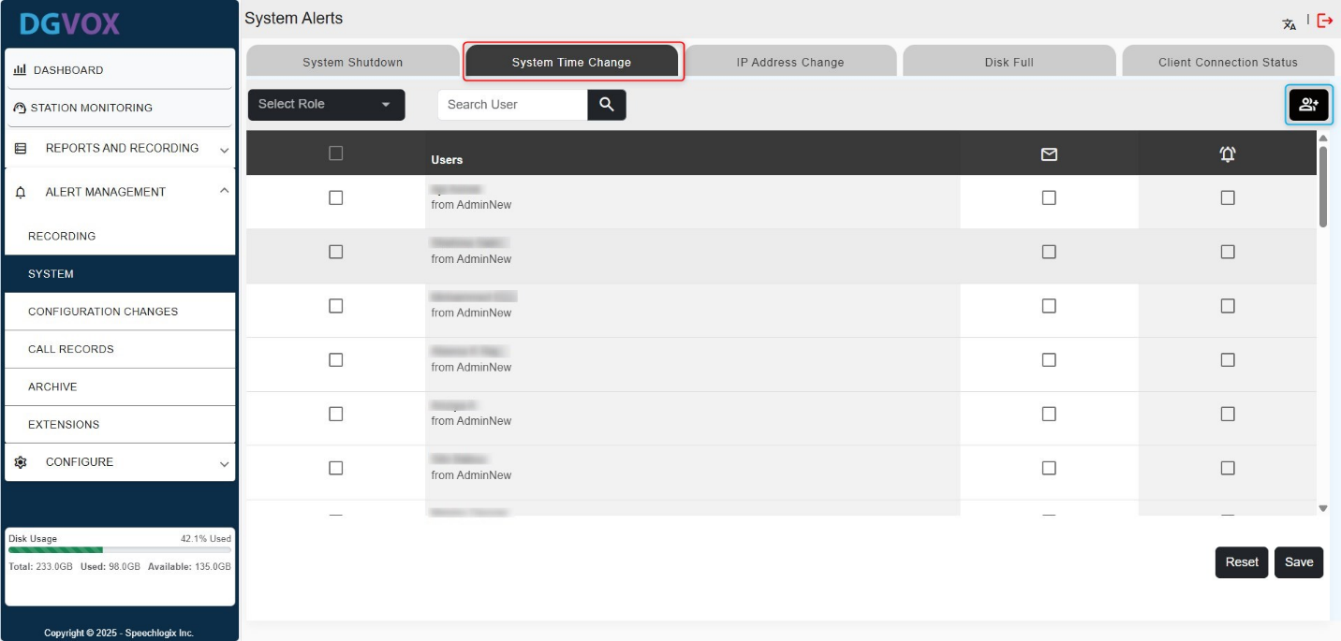

### **5.2.3. IP Address Change**

If the system's IP address changes, users receive an alert. This helps track connectivity changes or unauthorized modifications.

Navigate to **Alert Management**, select **System**, and then open the **IP Adddress Change** tab.

Next, click on the ‘**Set** **Users’** button and select the users you want to include in the list. You can also use the dropdown menu to choose specific roles and verify if those users have the necessary permissions. Finally, to activate email alerts and notifications, make sure to check the corresponding box next to each user.

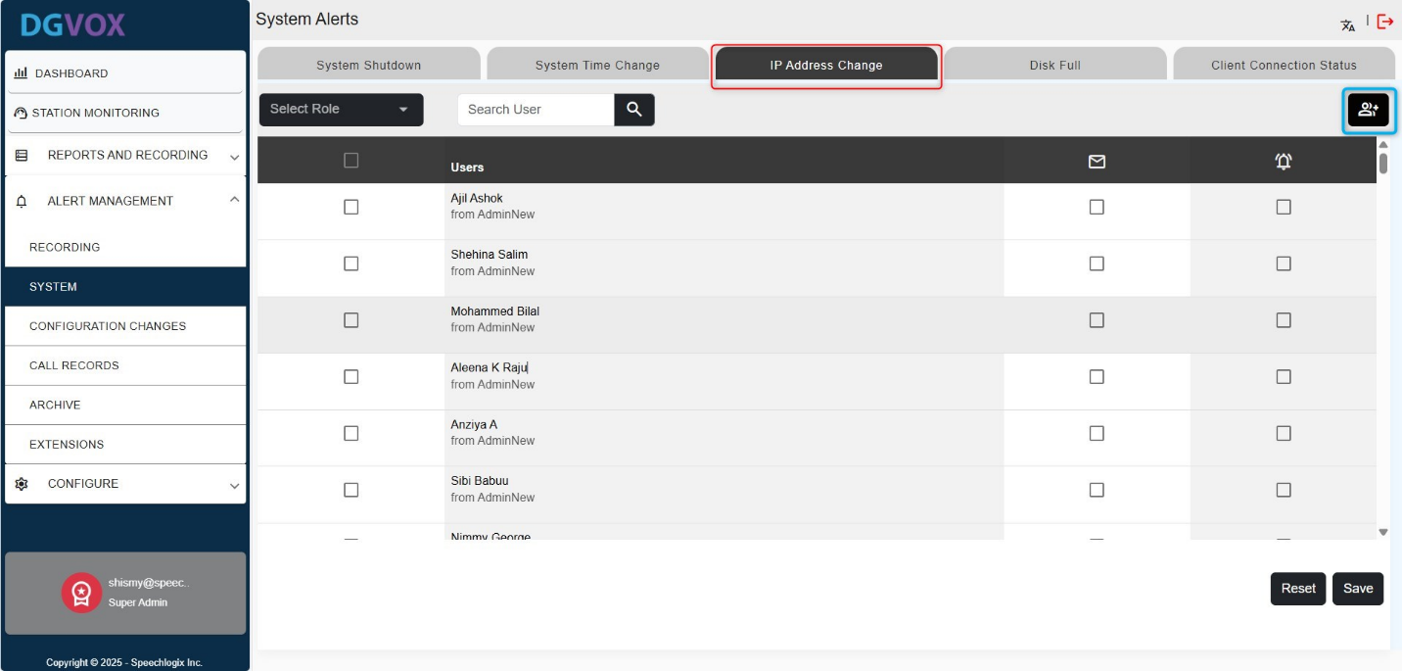

### **5.2.4. Disk Full**

When the disk space reaches the defined limit, an alert is triggered. A warning is first sent to a Level 1 user. If unaddressed and disk space remains low, a second alert is sent to a Level 2 user.

Navigate to **Alert Management**, select **System**, and then open the **Disk Full** tab.

Click the lock/unlock icon and adjust the disk storage percentage to the desired limit. Once the limit is reached, alerts will be automatically triggered and sent to users.

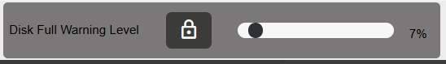

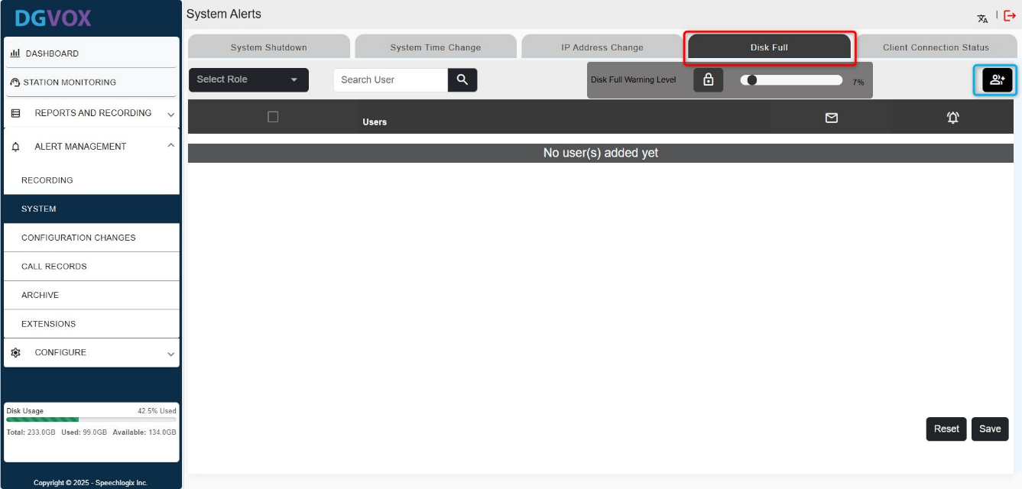Next, click on the ‘**Set** **Users’** button and select the users you want to include in the list. You can also use the dropdown menu to choose specific roles and verify if those users have the necessary permissions. Finally, to activate email alerts and notifications, make sure to check the corresponding box next to each user.

### **5.2.5. Client Connection Status**

Alerts that notify when connected clients go offline or lose connection.

Navigate to **Alert Management**, select **System**, and then open the **Client Connection Status** tab.

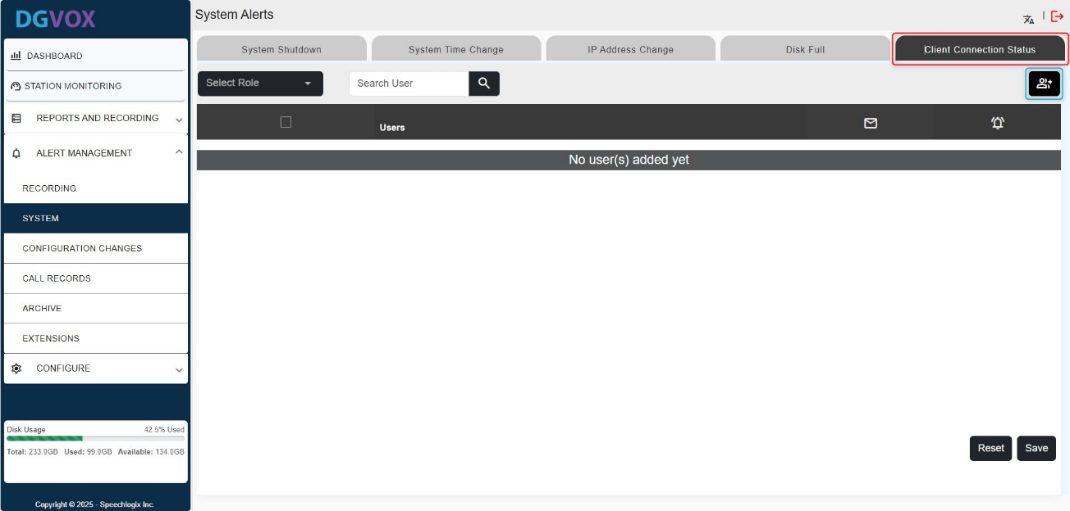Next, click the ‘**Set** **Users’** button and select the users you want to include. You can also use the dropdown menu to choose specific roles and verify if those users have the necessary permissions. Finally, to activate email alerts and notifications, make sure to check the corresponding box next to each user.

## **5.3. Configuration Changes Alert**

These alerts inform users when critical settings are modified within the DGVOX system, helping maintain system integrity and traceability.

### **5.3.1. Recorder Settings Change**

Alerts users when changes are made to the recording configuration, such as codec settings or channel assignments.

Navigate to **Alert Management**, select **Configuration Changes**, and then open the **Recorder Settings** tab.

Next, click the ‘**Set** **Users’** button and select the users you want to include. You can also use the dropdown menu to choose specific roles and verify if those users have the necessary permissions. Finally, to activate email alerts and notifications, make sure t

o check the corresponding box next to each user.

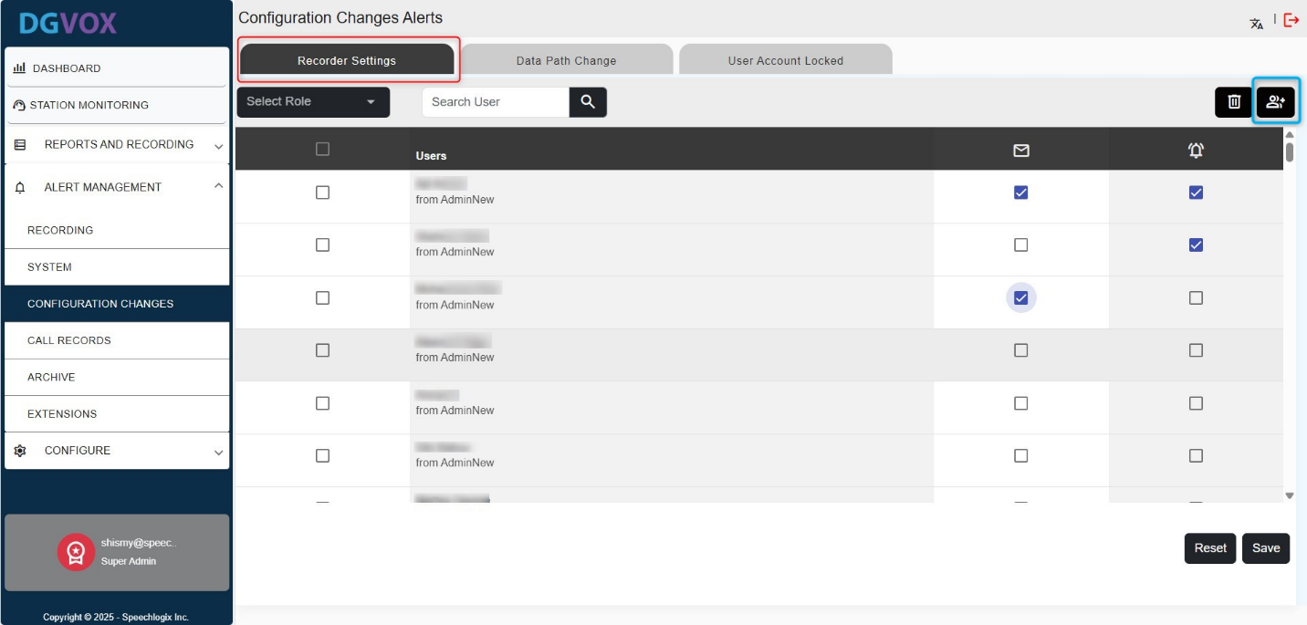

### **5.3.2. Data Path Change**

If the directory or location where recordings are stored is altered, a notification is sent to alert users of the change.

Navigate to **Alert Management**, select **Configuration Changes**, and then open the **Data Path Change** tab.

Next, click the ‘**Set** **Users’** button and select the users you want to include. You can also use the dropdown menu to choose specific roles and verify if those users have the necessary permissions. Finally, to activate email alerts and notifications, make sure to check the corresponding box next to each user.

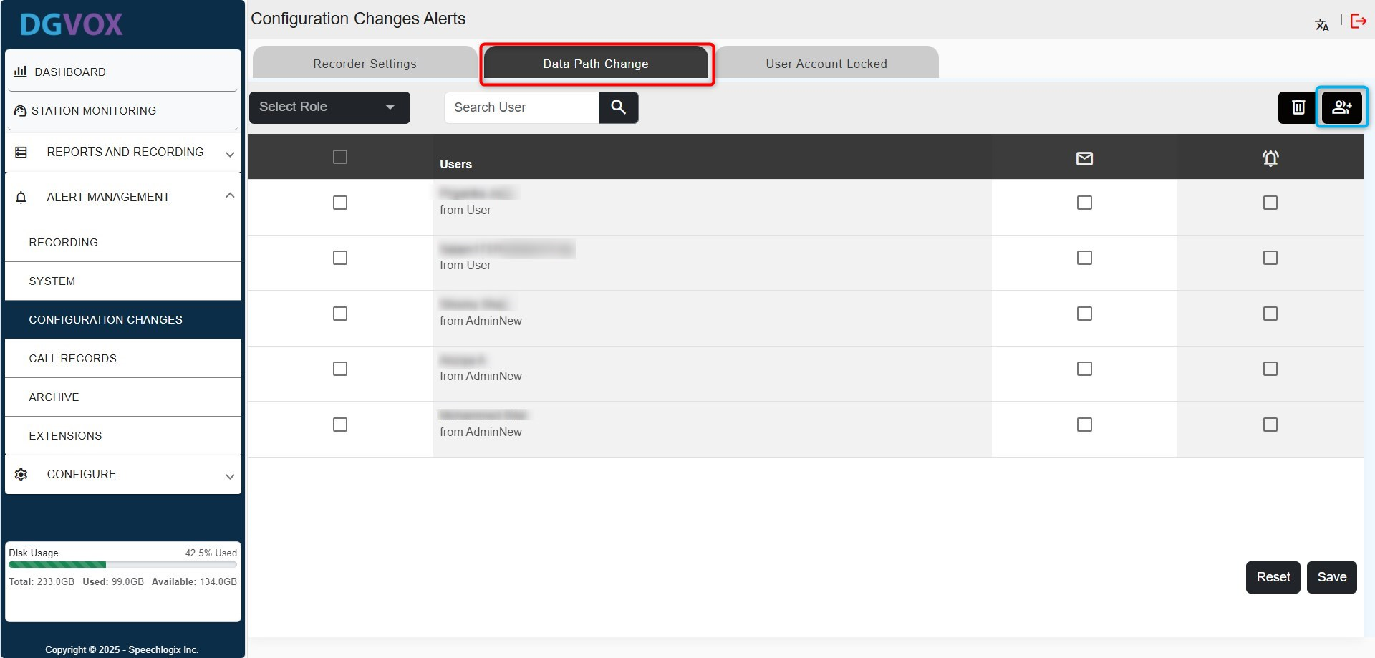

### **5.3.3. User Account Locked**

Sent when a user fails to log in after multiple incorrect password attempts (e.g., more than 5 tries). This indicates a possible security concern or user issue.

Navigate to **Alert Management**, select **Configuration Changes**, and then open the **User Account Locked** tab.

Next, click the ‘**Set** **Users’** button and select the users you want to include. You can also use the dropdown menu to choose specific roles and verify if those users have the necessary permissions. Finally, to activate email alerts and notifications, make sure to check the corresponding box next to each user.

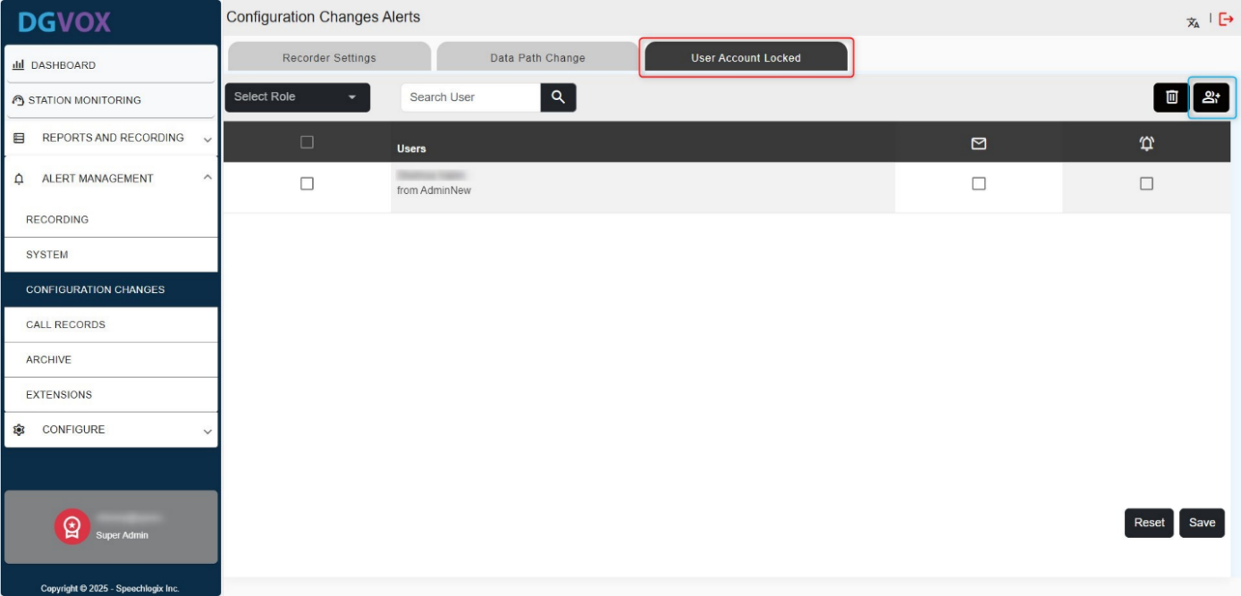

## **5.4. Call Records Deleted Alert**

When a call record is removed from the system, an alert is generated. The alert includes the IP address of the machine from which the deletion occurred. This helps ensure accountability and prevents unauthorized data removal.

Navigate to **Alert Management**, select **Call Records**, and then open the **Record Deleted** tab.

Next, click the ‘**Set** **Users’** button and select the users you want to include. You can also use the dropdown menu to choose specific roles and verify if those users have the necessary permissions. Finally, to activate email alerts and notifications, make sure to check the corresponding box next to each user.

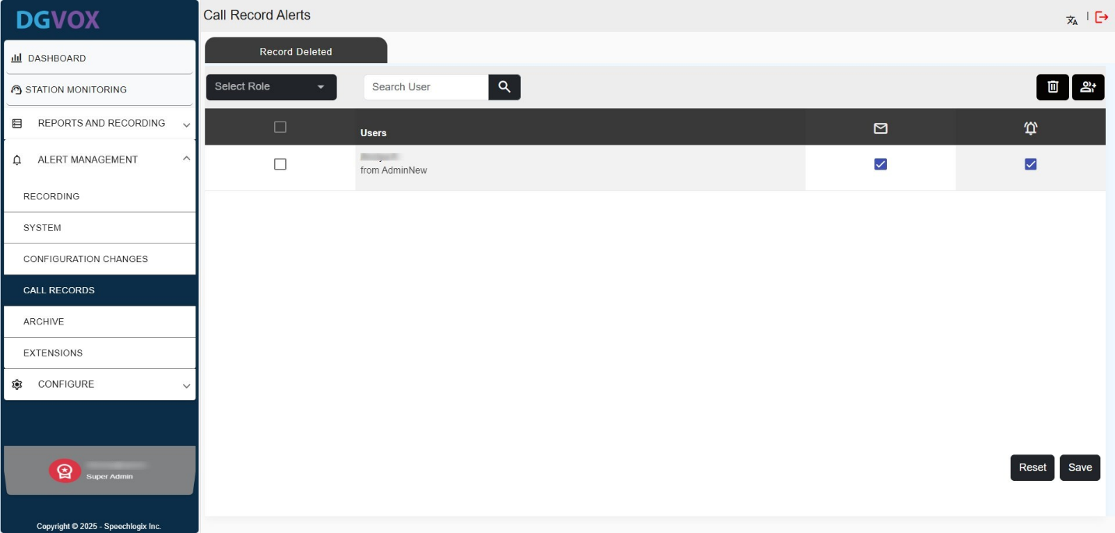

## **5.5. Archive Alerts**

The purpose of Archive Alerts is to keep users informed about the status of the archiving process. These alerts notify users when the number of call records reaches a specified threshold or when an archive operation succeeds or fails. This ensures timely action, efficient storage management, and helps maintain data integrity for future access.

### **5.5.1. Archive Status**

If an Archive fails to complete successfully, then an alert notification will be sent to the users in the alert subscription list. Similarly, the moment an archive gets completed successfully, an alert message will be sent to the user informing the same.

Navigate to **Alert Management**, select **Archive**, and then open the **Archive Status** tab.

Next, click the ‘**Set** **Users’** button and select the users you want to include. You can also use the dropdown menu to choose specific roles and verify if those users have the necessary permissions. Finally, to activate email alerts and notifications, make sure to check the corresponding box next to each user.

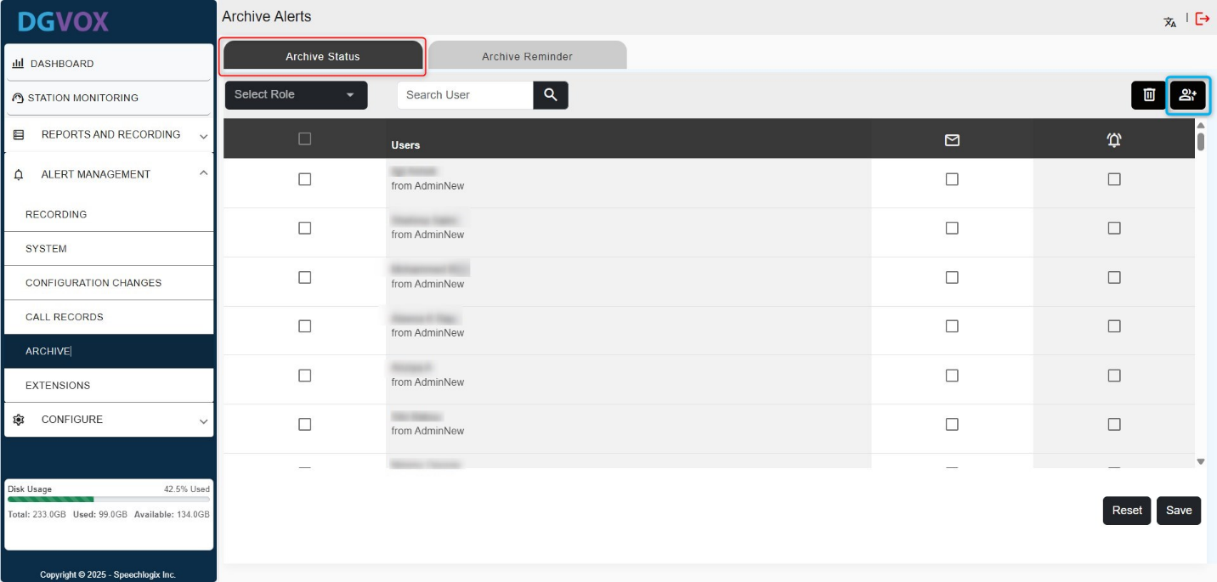

### **5.5.2. Archive Reminder**

When the number of call records reaches the user-defined threshold, an alert will be sent as a reminder. For example, if the limit is set to 1000, an alert will be triggered once 1000 call records are stored. This notification prompts the user to archive the records for future reference.

Navigate to **Alert Management**, select **Archive**, and then open the **Archive Reminder** tab.

Next, click the ‘**Set** **Users’** button and select the users you want to include. You can also use the dropdown menu to choose specific roles and verify if those users have the necessary permissions. Finally, to activate email alerts and notifications, make sure to check the corresponding box next to each user.

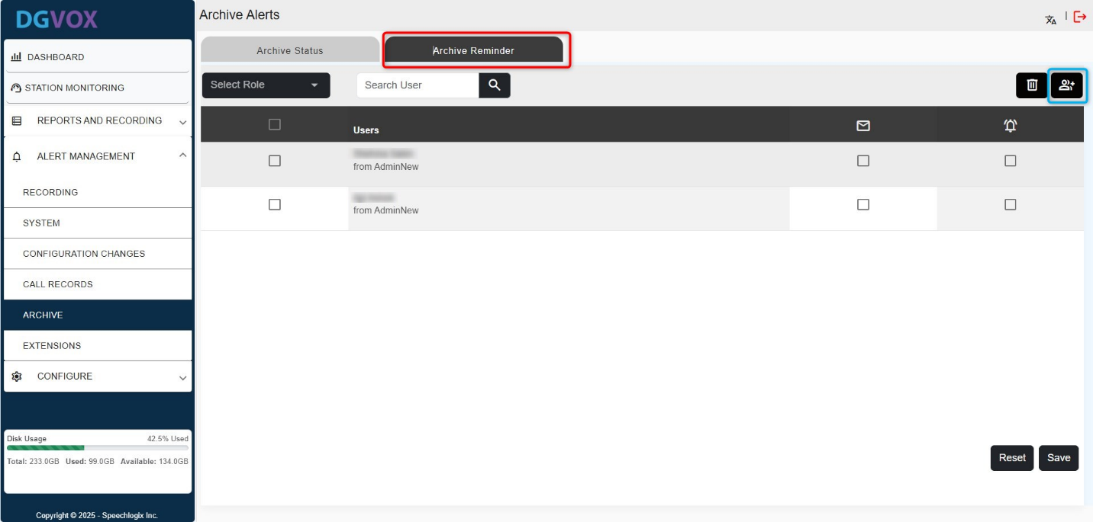

## **5.6. Extension Alerts**

* **Extension Busy**: This alert notifies users when one or more channels are occupied during specific time intervals on designated days of the week.

Navigate to **Alert Management**, select **Extension**, and then open the **Extension Busy** tab.

Next, click the ‘**Set** **Users’** button and select the users you want to include. You can also use the dropdown menu to choose specific roles and verify if those users have the necessary permissions. Finally, to activate email alerts and notifications, make sure to check the corresponding box next to each user.

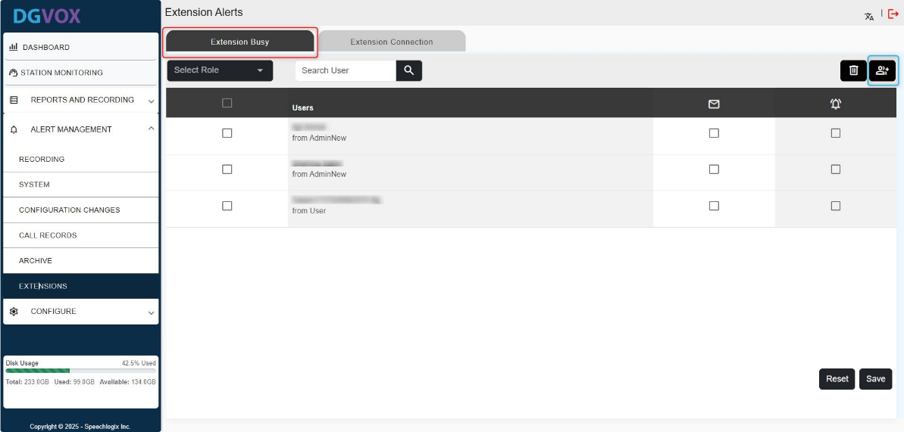.

* **Extension Connection**: Users receive a notification whenever a channel is either connected or disconnected.

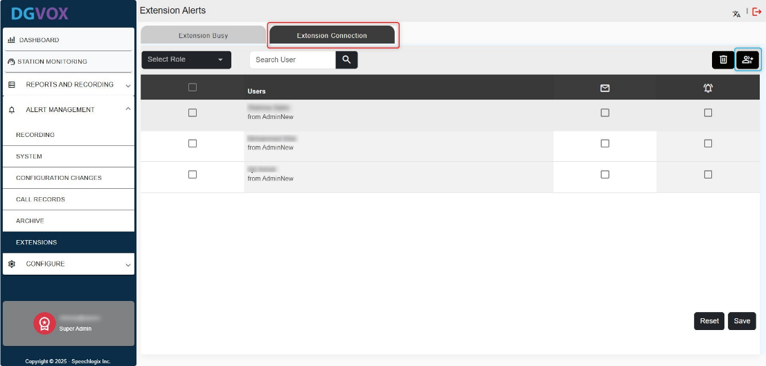Navigate to **Alert Management,** select **Extension**, and then open the **Extension Connection** tab. Next, click the ‘**Set** **Users’** button and select the users you want to include. You can also use the dropdown menu to choose specific roles and verify if those users have the necessary permissions. Finally, to activate email alerts and notifications, make sure to check the corresponding box next to each user.

# **6. System Configuration**

The **System Configuration** section serves as the central hub for setting up and managing the core operational components of the platform. It allows administrators to define how the system behaves, who can access what, and how users are organized. Proper configuration ensures seamless functionality, security, and efficient user management across the entire system.

## **6.1. Employee Management**

The **Employee Management** allows administrators to efficiently manage user records within the system. It includes functionalities to **add**, **import**, **edit**, **delete**, and **view** employee information.

Go to the **Configure** menu, select **Employee** **Management**, and click on the "**Add** **Employee**" button to open a form for manually adding and registering a new employee.

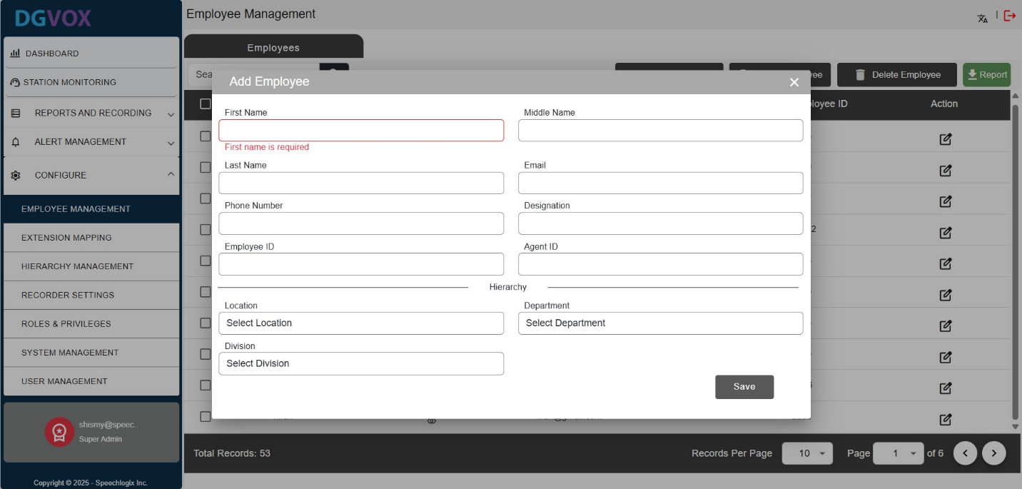

|  |  |
| --- | --- |
| **Fields** | **Description** |
| **First Name** | Enter the employee’s first name. This field is mandatory. |
| **Middle Name** | Enter the employee’s middle name, if applicable. |
| **Last Name** | Enter the employee’s last name or surname. |
| **Email** | Enter a valid email address for the employee. Required for notifications. |
| **Phone Number** | Enter the employee’s contact number. |
| **Designation** | Specify the employee’s job title or role within the organization. |
| **Employee ID** | Unique identifier for the employee; must be at least 4 characters long. |
| **Agent ID** | Used for agent tracking; helpful in environments like call centers. |
| **Location** | Select the location (office or branch) where the employee is based. |
| **Department** | Select the department (e.g., HR, IT, Sales) the employee belongs to. |
| **Division** | Choose the specific division under the selected department. |

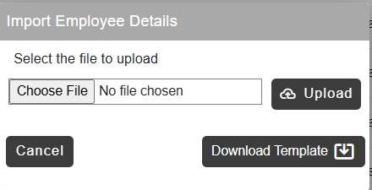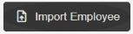Alternatively, to add multiple employee records at once, click the "**Import Employee**" button. A popup window will appear, download the provided template, fill in the required employee details, save the file, and then upload it to complete the import process.

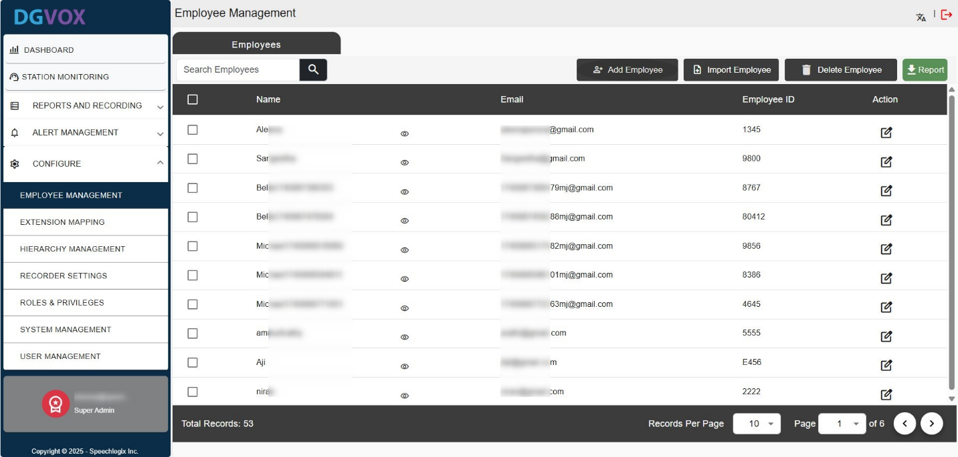Once the information is saved, it will appear on the screen as shown below, with options available to edit or delete the entry.

To ***modify an employee's details***, click the edit icon next to the respective row. A popup window will appear displaying the current information. Make the necessary changes and click the "**Update**" button to save them.

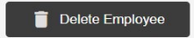To ***remove records***, select the checkboxes next to the desired rows, then click the "Delete" button. A confirmation prompt will appear, confirm the action to permanently delete the selected records from the list.

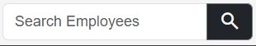**Search Employees**: A search bar that allows users to quickly find employees by name or email.

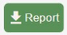**Report Button**: Exports or generates a report of employee data, useful for audits or backups.

## **6.2. Extension Assignment**

The **Extension Mapping** allows you to assign telephone extensions to employees, along with their corresponding location, department, and division within the organization.

Go to the **Configure** menu, select **Extension Mapping**, and click on the "**Add** **Extension Mapping**" button to open a form for assigning extensions to employees.

|  |  |
| --- | --- |
| **Fields** | **Description** |
| **Extension** | A dropdown to select the telephone extension number to be mapped. It will display only unmapped extensions.  You can also **create a new extension** by entering the extension number in the provided field and pressing the Enter key, which will add the new extension. |
| **Extension Label** | Text field to assign a custom name or label for the selected extension. |
| **Location** | Dropdown to select the location (site or branch) where the extension is based. |
| **Department** | A dropdown to select the department under the chosen location. |
| **Division** | A dropdown to select the division within the selected department. |
| **Employee ID** | A Dropdown to select the employee's ID to link the extension to a specific employee. |
| **Employee Name** | The employee's name is automatically filled in after selecting the Employee ID from the dropdown, linking the employee to the extension. |

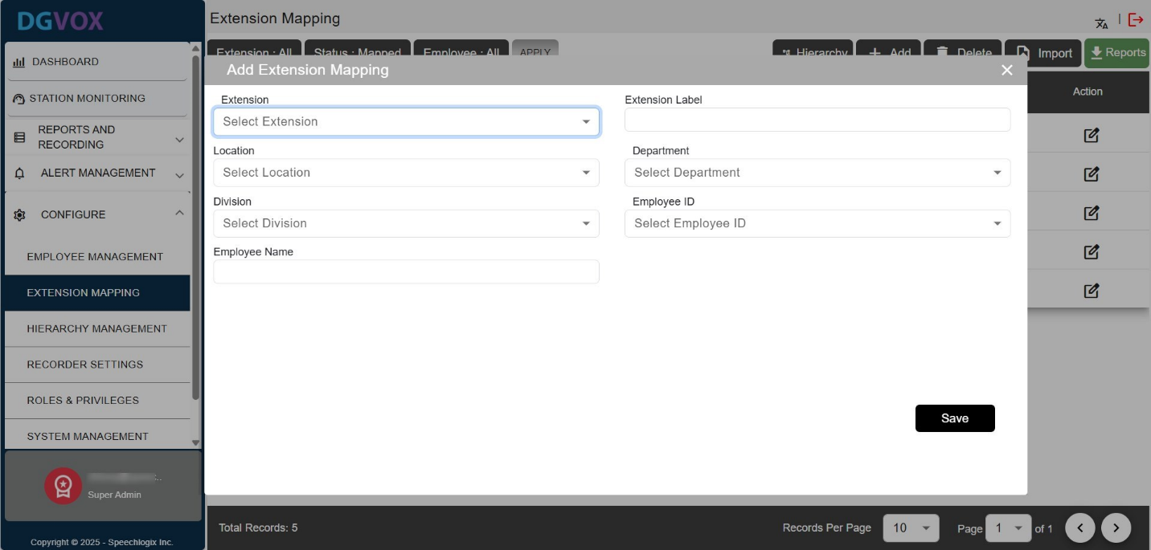

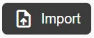

Alternatively, to add multiple records at once, click the "**Import**" button. A popup window will appear, download the provided template, fill in the *Extension* and *Employee* *ID* columns, save the file, and then upload it to complete the import process.

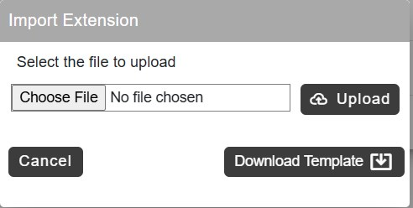***Please note that you can only upload extensions and employee IDs that already exist in the system.***

After saving the information, it will be displayed on the screen as shown below. To assign a hierarchy to the extensions, you can either *edit the details* individually or select the checkboxes, click the **Hierarchy** button, choose the location, department, and division, and then click the **Apply** button.

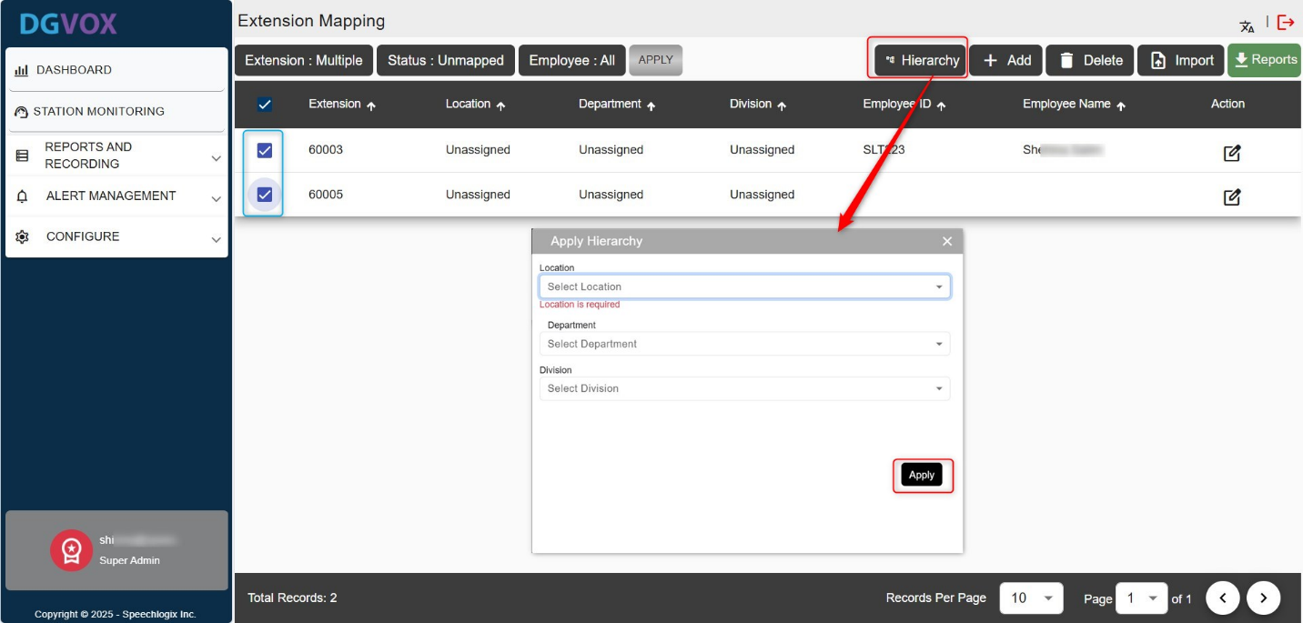

Once you set the hierarchy to the extension, a screen will appear as shown below with options available to edit or delete the entry.

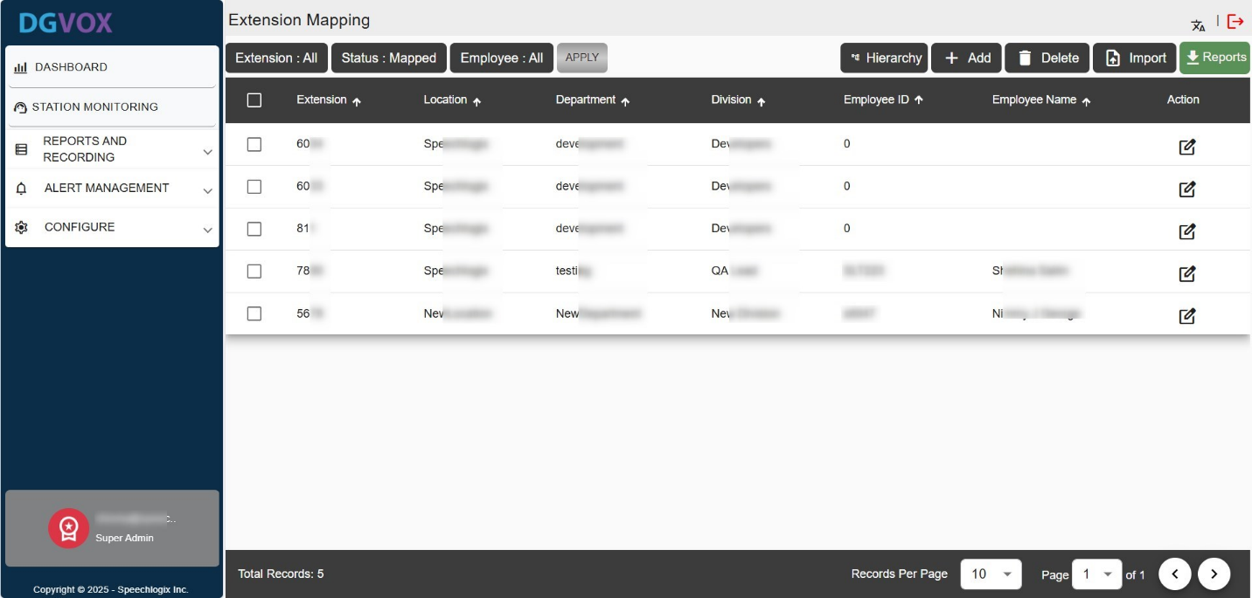

To ***modify the details***, click the edit icon next to the respective row. A popup window will appear displaying the current information. Make the necessary changes and click the "**Update**" button to save them.

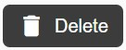

To ***remove records***, select the check boxes next to the desired rows, then click the "**Delete**" button. A confirmation prompt will appear, confirm the action to permanently delete the selected records from the list.



**Report Button**: Exports or generates a report of data in Excel or PDF format.

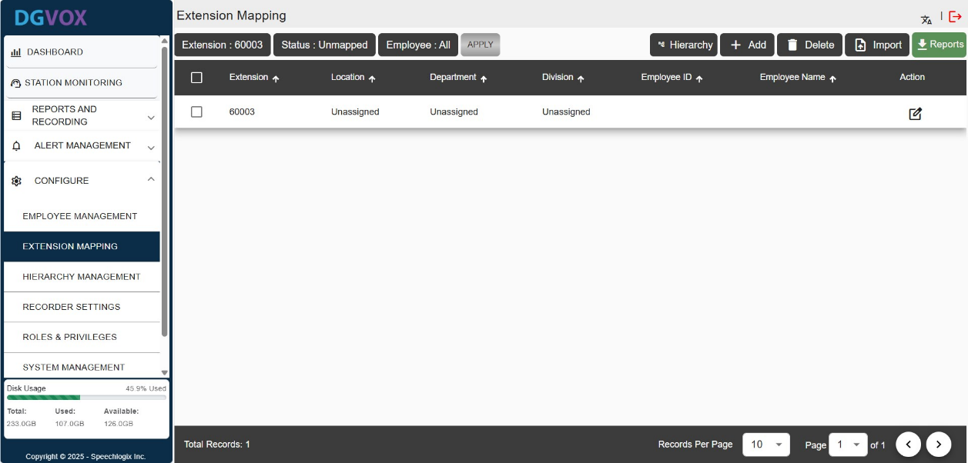The top filter bar enables you to filter the details by *Extension, Status, and Employee*. By applying these filters, you can refine the results to identify which extensions are mapped or unmapped. After selecting your filters, click the "**Apply**" button to view the filtered results.

## **6.3. Organizational Hierarchy Setup**

The **Hierarchy Management** allows administrators to organize and manage organizational hierarchies across three levels:

1. **Location**: Represents physical or logical sites.
2. **Department**: Departments belong to a location. Represents business units within a location.
3. **Division**: Divisions are smaller groups within a department. Represents sub-sections under departments.

Go to the **Configure** menu, select **Hierarchy Management**.

* **Adding a New Location**: Click the ‘Add’ icon. An input field will appear at the top of the location list. Enter the location name and click ‘Save’.
* **Adding a New Department**: First, select the desired location. Then, click the ‘Add’ icon in the department section. Enter the department name in the provided field and click ‘Save’.
* **Adding a New Division**: Follow the same steps as above. Select the relevant location and department, click the ‘Add’ icon in the division section, enter the division name in the input field, and click ‘Save’.

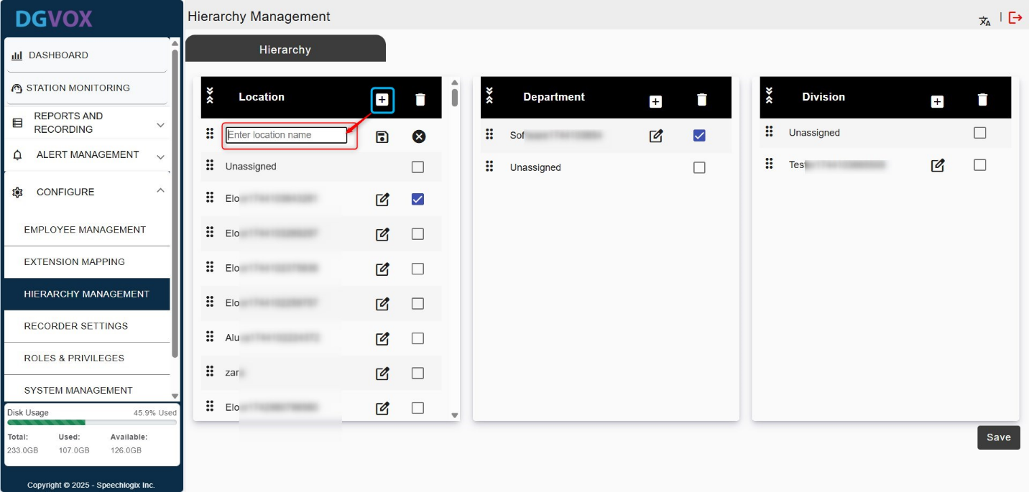

## **6.4. Recorder Configuration**

The **Recorder Configuration** section in DGVOX provides comprehensive controls for setting up how the system captures and manages call recordings. This is crucial for ensuring compatibility with different telephony environments (SIP, IP-PBX, analog, E1, etc.), assigning resources (channels), and facilitating integration with third-party systems.

### **6.4.1. Recorder Channel Index Settings**

The **Channel Index Settings** allows administrators to assign starting index numbers for each type of recording channel, effectively mapping them to specific hardware interfaces or virtual inputs.

This setting ensures that every type of recorder (digital, analog, IP-based, active/passive, E1) receives a **unique range of channel indexes**. This prevents overlap and confusion in recorded data mapping and playback.

Each recorder type has an associated input field to define the **starting channel index**, which corresponds to the first channel used by that recorder. The number of channels it handles (e.g., 5 or 10) will be allocated sequentially starting from this value.

* **Digital Recorder**: Used for older or digital phone systems that need special connections to record calls. You can choose how many channels it records using the dropdown.
* **Passive IP Recorder**: Listens to call data by copying network traffic (using port mirroring). Ideal for VoIP setups where you don't want to interfere with the main system.
* **Active IP Recorder**: Connects directly to phone systems using software links or APIs, allowing it to record calls with extra details like who made the call and when.
* **Analog Recorder**: Records calls from regular analog phone lines, often used in smaller or older systems.
* **E1 Recorder**: Records calls from E1 digital lines, which can carry about 30 calls at the same time.

To set channel indexes, **select** the starting index number from the dropdown. Ensure the index does **not overlap** with others. The range should cover the number of channels. E.g., if set to 015 with 5 channels, it will cover 015-019. Click **Save** at the bottom right to apply changes.

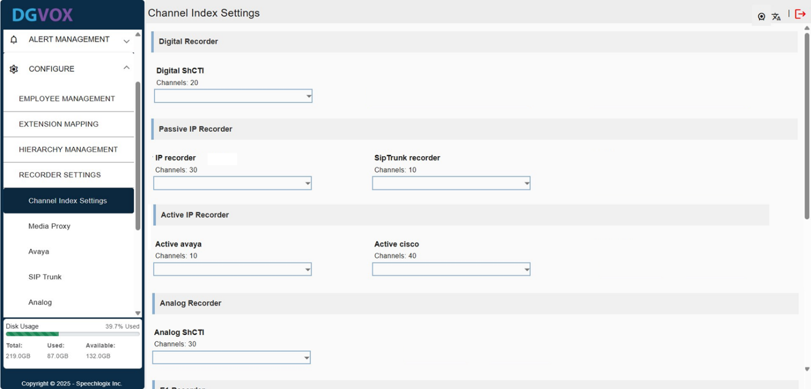

### **6.4.2. Media Proxy**

The Media Proxy menu configures the media proxy related to a recorder system. It handles the routing and management of the media streams between different devices or systems.

Go to the **Configure** menu, select **Recorder settings**, and click the "**Media Proxy**". A form will appear as shown below.

|  |  |
| --- | --- |
| **Field** | **Description** |
| **Data Driver** | Path to the data drive used by the system, e.g., /opt/app/DATA, indicating the storage location. |
| **Session Port** | Port number for session communication. |
| **Media Forward IP** | IP address used to forward media traffic to the container IP for the media server. |
| **Local IP** | Local IP address of the media proxy container. |
| **Number of Channels** | Number of available channels for media communication. |
| **Log Status** | Current log status of the system.   |  |  | | --- | --- | | **OFF** | Logging is completely disabled. No system events, errors, warnings, or information are recorded. | | **Fatal**  **Error** | Only the most critical errors are logged, issues that cause the system or service to fail completely. | | **General Error** | Logs all major errors that affect functionality but might not immediately crash the system. | | **Warning** | Log potential issues that are not critical but could lead to problems if not addressed. The system continues to work, but warnings act as early signs of underlying problems. | | **Information** | Records general system events, such as successful operations, state changes, or regular activity updates. Useful for monitoring system behaviour and understanding the flow of events. | | **Debug** | Provides very detailed, low-level information about system operations for developers or technical support to trace and troubleshoot problems. | |
| **Mediaserver Port** | Port number for managing the media server communication. |
| **Mediaserver Return Port** | The port number is used to return connections from the media server. |
| **Set Extension as Agent** | Option to define whether an extension is set as an agent. |
| **Avaya Active** | Only enable if the Avaya active recording is actively using. |

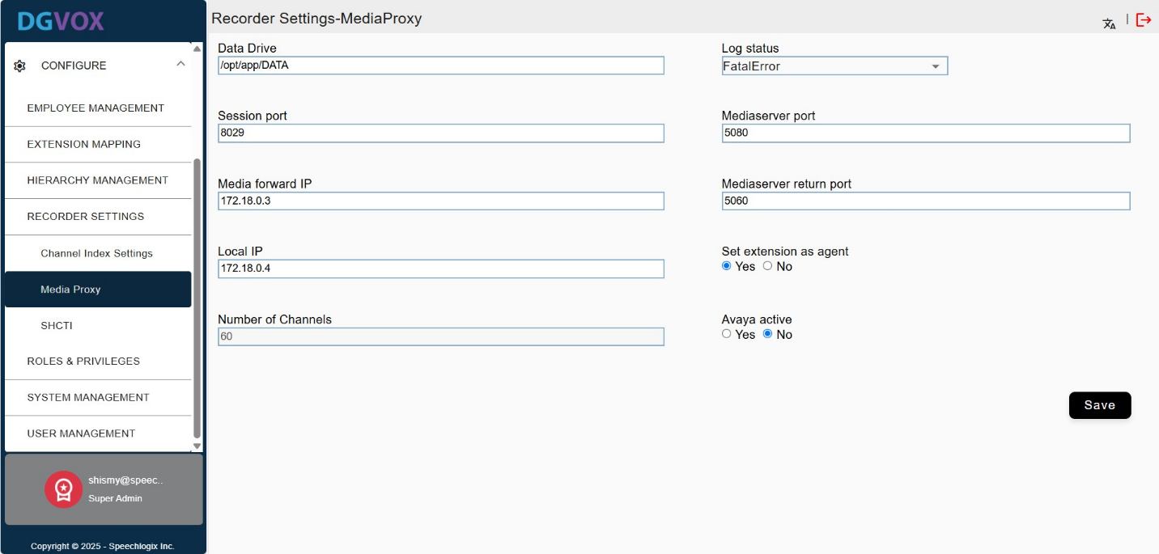

### **6.4.3. CTI Plugins IP Recordings**

This menu is used to configure **SHCTI recording endpoints**, including how they handle media routing, session logging, channel usage, and metadata collection (like digits pressed). It's essential for ensuring accurate and complete call recording, managing system capacity, routing audio data through proper media handling components and enabling advanced logging and diagnostics for support and maintenance.

#### **6.4.3.1. SHCTI Settings**

Go to the **Configure** menu, select **Recorder settings**, and click the "**SHCTI Settings**" tab. A form will appear as shown below.

|  |  |
| --- | --- |
| **Field** | **Description** |
| **Data Drive** | Specifies the file path where all recorded media and session data will be stored. Example: /opt/app/DATA. |
| **Media Forward IP** | IP address used to forward media streams to the designated media server container. |
| **Recording Mode** | Defines the mode of recording. Example: MAC indicates recording is tied to the MAC addresses of endpoints. |
| **Media Proxy IP** | IP address of the media proxy container that handles media routing and relaying. |
| **Number of Channels** | Sets the number of concurrent recording channels the SHCTI module can handle. |
| **Log Status** | Determines the level of detail captured in system logs. Options include OFF, Fatal Error, General Error, Warning, Information, and Debug. |
| **Channel Index** | Sets the starting index for IP recorder channels; useful for organizing and mapping channels systematically. |
| **Auxiliary Recordings** | Enables or disables additional (secondary) recordings for backup or special use cases. |
| **Digits From Display** | When enabled, the system captures digits shown on the telephony display (e.g., incoming numbers). |
| **Digits Pressed** | Enables capturing of DTMF tones - digits dialed or pressed by the caller during a call. |

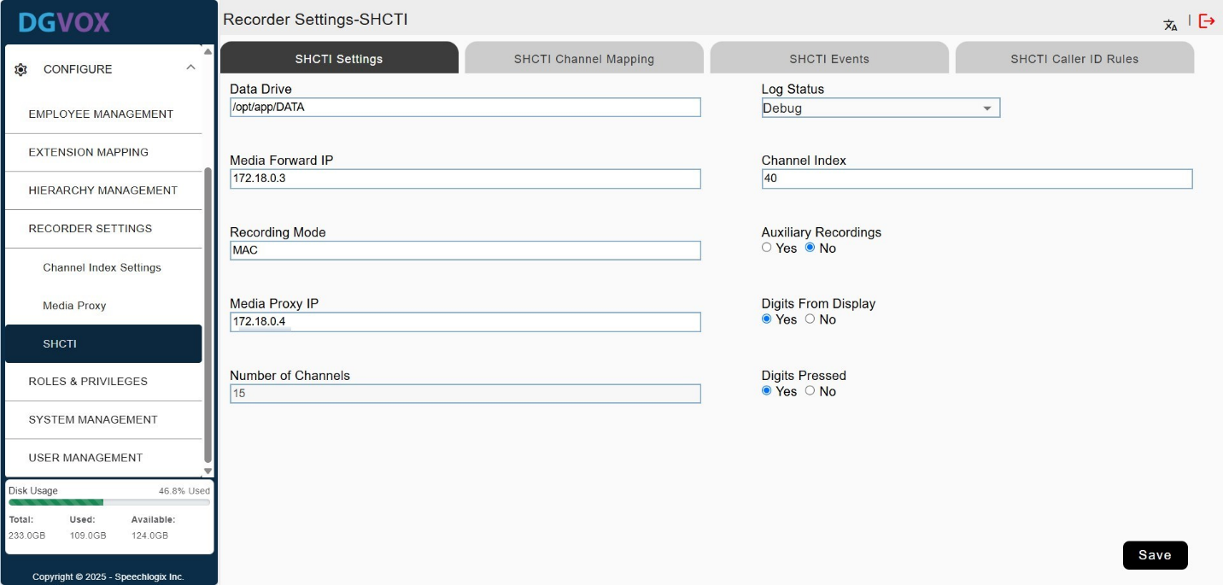

#### **6.4.3.2. SHCTI Channel Settings**

The SHCTI Channel Mapping settings tab is used to define and manage the association between physical or logical recording channels and their corresponding telephony extensions, MAC addresses, and hardware identifiers. This mapping ensures that audio data is accurately linked to the correct source (e.g., a phone extension or device).

Go to the **Configure** menu, select **Recorder settings**, and click the "**SHCTI Channel Mapping**" tab. A form will appear as shown below.

|  |  |
| --- | --- |
| **Column** | **Description** |
| **Channel** | The unique identifier for the recording channel. |
| **Extension** | The telephone extension is associated with the channel. This helps identify which user or device is being recorded. |
| **MAC** | The MAC address of the network device (e.g., phone or interface) linked to the extension and channel. |
| **Board ID** | In your context, the Board ID is a unique identifier for each CTI (Computer Telephony Integration) card used in the DGVox application. These identifiers distinguish various cards based on their model, functionality, and channel capacity, providing a clear reference for system configuration and operation. |

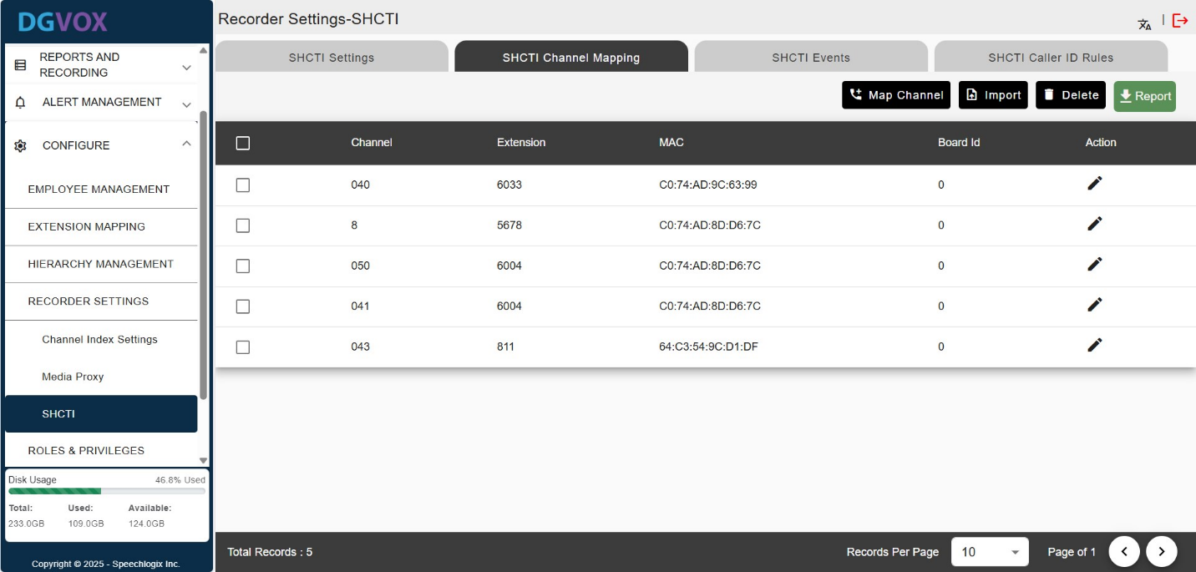

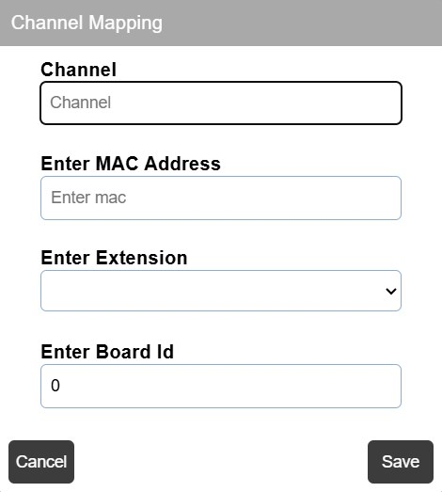To map a channel, click on the “**Map** **Channel**” button, it opens a pop-up window tocreate a new mapping between a channel, extension, and MAC address.

Alternatively, to add multiple records at once, click the "**Import**" button. A popup window will appear, download the provided template, fill in the details, save the file, and then upload it to complete the import process.

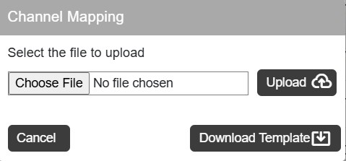

To ***modify the details***, click the edit icon next to the respective row. A popup window will appear displaying the current information. Make the necessary changes and click the "**Update**" button to save them.



To ***remove records***, select the check boxes next to the desired rows, then click the "**Delete**" button. A confirmation prompt will appear, confirm the action to permanently delete the selected records from the list.

**Report Button**: Exports or generates a report of data in Excel or PDF format.

#### **6.4.3.3. SHCTI Events**

This is used to define event mappings for categorizing and processing telephony events.

Go to the **Configure** menu, select **Recorder settings**, and click the "**SHCTI Events**" tab. A form will appear as shown below.

|  |  |
| --- | --- |
| **Field** | **Description** |
| **Missed Call** | Allows configuration of event types that should be categorized as missed calls. The following events are selected:   * **DST_CALL_ABANDONED**: A call that was dropped before being answered. * **DST_CALL_REJECTED**: A call that was explicitly rejected. |
| **Call Info** | Events related to general call information. Selected types include:   * **DST_CISCO_SCCP_CALL_INFO**: Likely a Cisco-specific event related to SCCP call metadata. * **DST_CALL_CONNECTED**: Indicates a call was successfully connected. * **DST_MSG_CHG**: Captures changes in the phone display message as an event. |
| **Direction** | Specifies call direction-related events (incoming or outgoing ring behavior). Chosen event types are:   * **DST_RING_ON:** Phone is ringing. * **DST_RING_OFF:** Ringing has stopped (call answered or dropped). * **DST_CALL_ALERTING:** The system is alerting the user of an incoming call. |

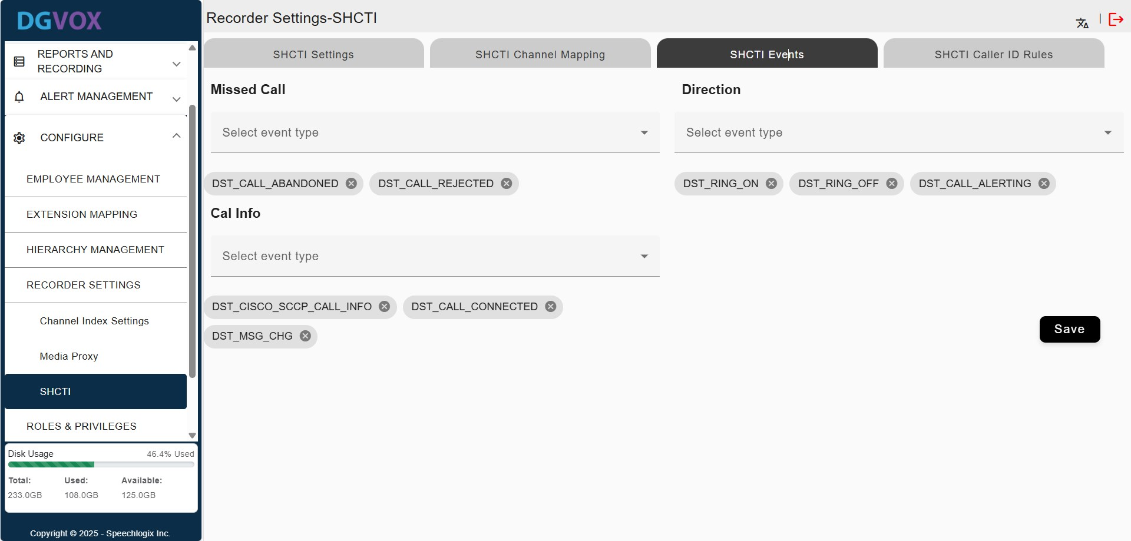

#### **6.4.3.4. SHCTI Caller ID Rules**

This configuration area is used to define how Caller ID data is interpreted, filtered, and cleaned before it’s stored or displayed in reports or dashboards.

Go to the **Configure** menu, select **Recorder settings**, and click the "**SHCTI Caller ID Rules**" tab. A form will appear as shown below.

|  |  |
| --- | --- |
| **Field** | **Description** |
| **Caller ID Minimum Length** | Specifies the **minimum number of characters** a Caller ID must have to be considered valid. |
| **Caller ID Start Position** | Specifies the character position in the phone display message where the Caller ID extraction begins. |
| **Caller ID Maximum Length** | Sets the **upper limit** for the length of the Caller ID. Any characters beyond this will be ignored. |
| **Caller ID End Position** | Defines the final character position in the phone display message up to which the Caller ID is extracted. |
| **Parse Digits** | Determines whether only numeric digits should be parsed from the Caller ID.  If set to **Yes**, it would strip out any non-digit characters (e.g., hyphens, letters). |
| **Phone Display Strings To Be Neglected** | This section lists **unwanted substrings** that should be ignored when parsing Caller ID.  These are typically: *System messages, Time durations, Protocol indicators, Null characters, Non-relevant prefixes/suffixes*.  The system strips these patterns to ensure a **clean Caller ID display** in recordings or logs |

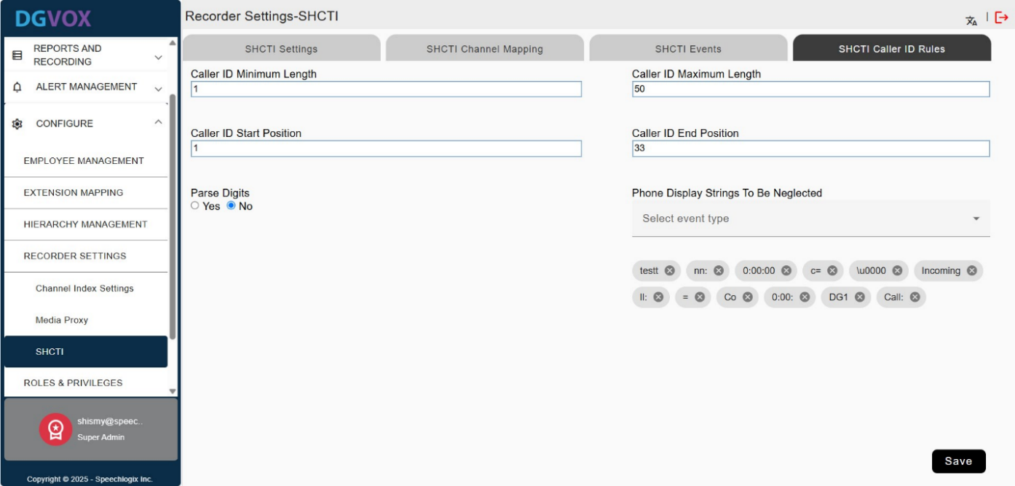

## **6.5. Role-Based Access Control**

The menu is used to manage user permissions and organizational access levels. It allows administrators to assign specific privileges and hierarchical visibility to individual users. The roles displayed here are sourced from LDAP and user groups created within the *User Management* menu.

**Note:** To create user groups, please see the ‘*User Group Filter*’ section.

Go to the **Configure** menu, select **Roles & Privileges**.

**1. Roles (Left Panel)**

* Displays a list of all users grouped under defined roles.
* Each user's name is listed and can be selected individually.
* A search bar is provided to quickly locate users by name.

**2. Privileges (Middle Panel)**

* Shows all the accessible features/modules that can be enabled or disabled for the selected user.

**3. Hierarchy Filter (Right Panel)**

* Displays organizational units or departments the user can access.
* The user can be granted access to specific using checkboxes.
* Allows control over what data a user can see or manage based on organizational structure.

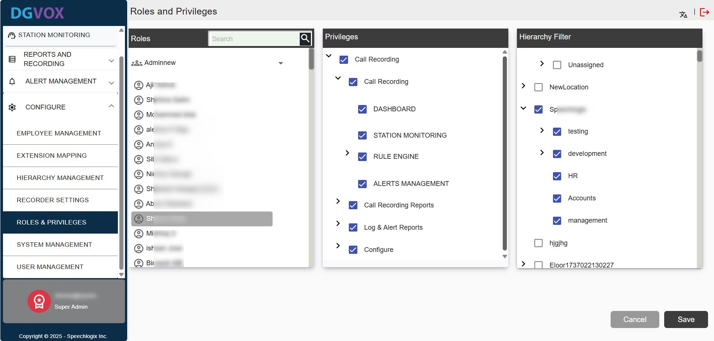

## **6.6. System Settings & Maintenance**

This System Management covers the essential system configuration and maintenance options. Here, users can manage various settings related to the registration process, mail configuration, data archiving, and automated data deletion. The section consists of four key tabs:

1. **Registration Details**: Configure and manage user registration parameters and associated settings.
2. **Mail Settings**: Set up and maintain email server settings for system notifications and communication.
3. **Data Archive Settings**: Configure the data archiving process, defining how and when data should be archived.
4. **Auto-Delete Settings**: Manage automated data deletion rules to ensure proper data lifecycle management.

### **6.6.1. Registration Details**

The **Registration Details** menu is used to capture and manage essential information about an organization. This menu is typically accessed during the initial setup or onboarding process and can also be revisited to update organizational data as needed.

Go to the **Configure** menu, select **System** **Management**, and click the "**Registration Details**" tab. A form will appear to enter and edit the details.

|  |  |
| --- | --- |
| **Field** | **Description** |
| **Organization** | Enter the organization name. |
| **Change Logo** | Option to change the organization’s logo by uploading a new image. |
| **Address 1** | Specify the primary address of the organization |
| **Address 2** | Specify the secondary address line for additional address details |
| **City** | The city where the organization is located. |
| **State** | The state or province where the organization is located. |
| **Phone** | Main contact phone number for the organization (landline or mobile). |
| **Fax** | Enter the fax number if the organization uses a fax line. |
| **Email** | Enter the official email address associated with the organization for communications and support. |
| **Website** | Enter the official URL of the organization's website. |
| **License** | The license is automatically created using the serial key. |
| **Serial Key** | The serial key is a unique identifier that includes the Machine ID of the system where the DGVOX setup is installed. It is required whenever the system is upgraded. |

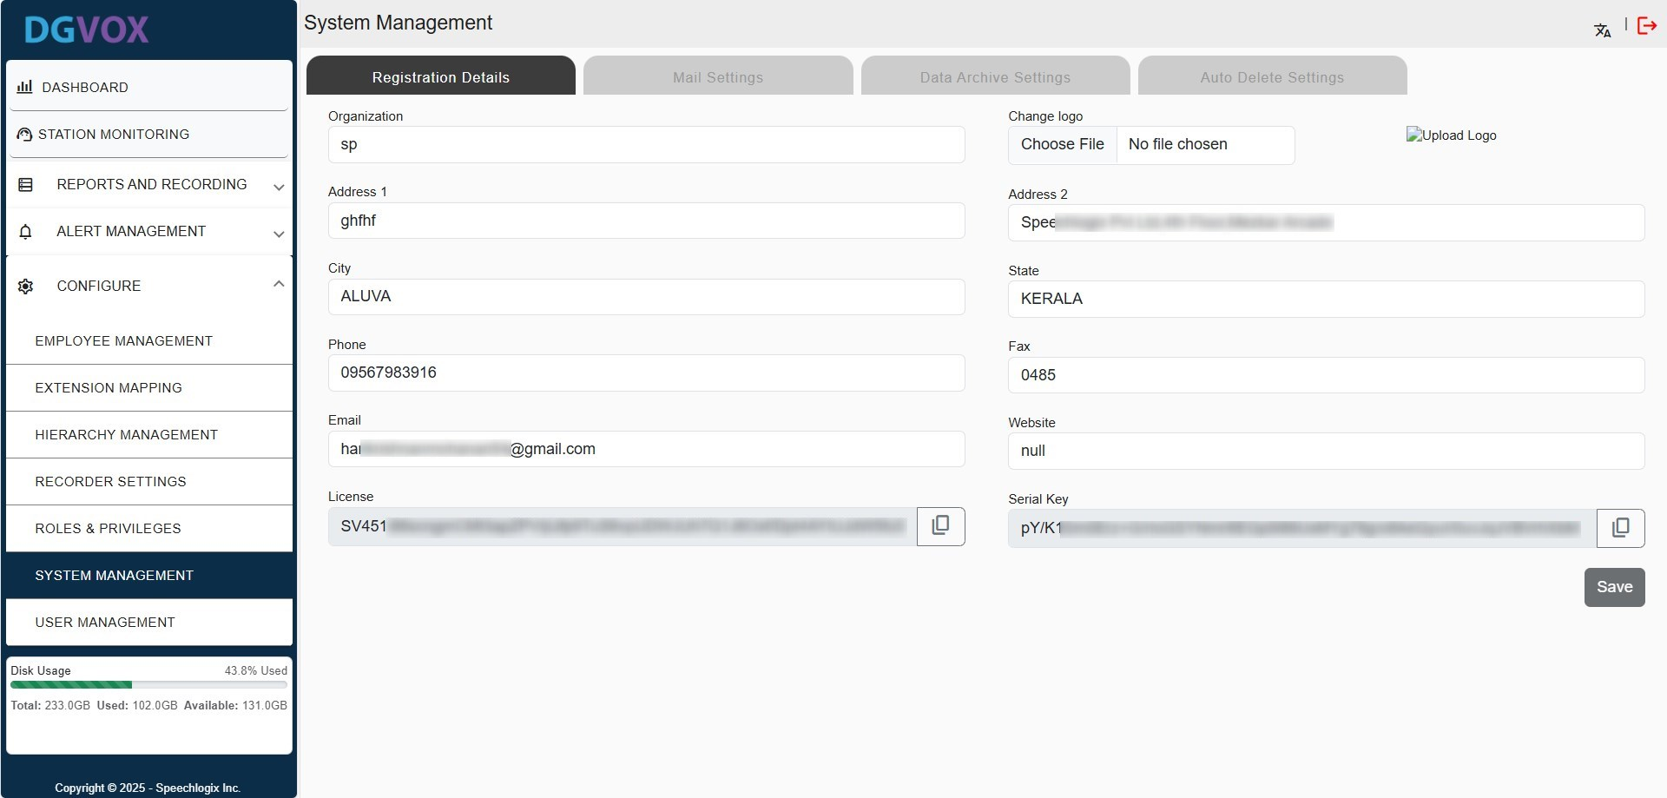

### **6.6.2. Mail Settings**

These Mail Settings allow configuration of the SMTP (Simple Mail Transfer Protocol) server, which is used to send emails from the application. Correct SMTP settings ensure that the system can send notifications, reports, and alert emails.

Go to the **Configure** menu, select **System** **Management**, and click the "**Mail Settings**" tab to open a form.

|  |  |
| --- | --- |
| **Field** | **Description** |
| **SMTP Port** | Specifies the port number used by the SMTP server. Common values are 465 (SSL), or 587 (TLS). |
| **Sender Email** | The email address that appears in the "From" field of outgoing emails. |
| **Username** | The username (usually the email address) is used to authenticate with the SMTP server. |
| **Password** | The password associated with the SMTP username. Used for secure authentication. |
| **Enter SMTP Password** | Input field to enter or update the SMTP password securely. |
| **Enable SSL** | A checkbox to enable SSL encryption for secure communication with the mail server. |

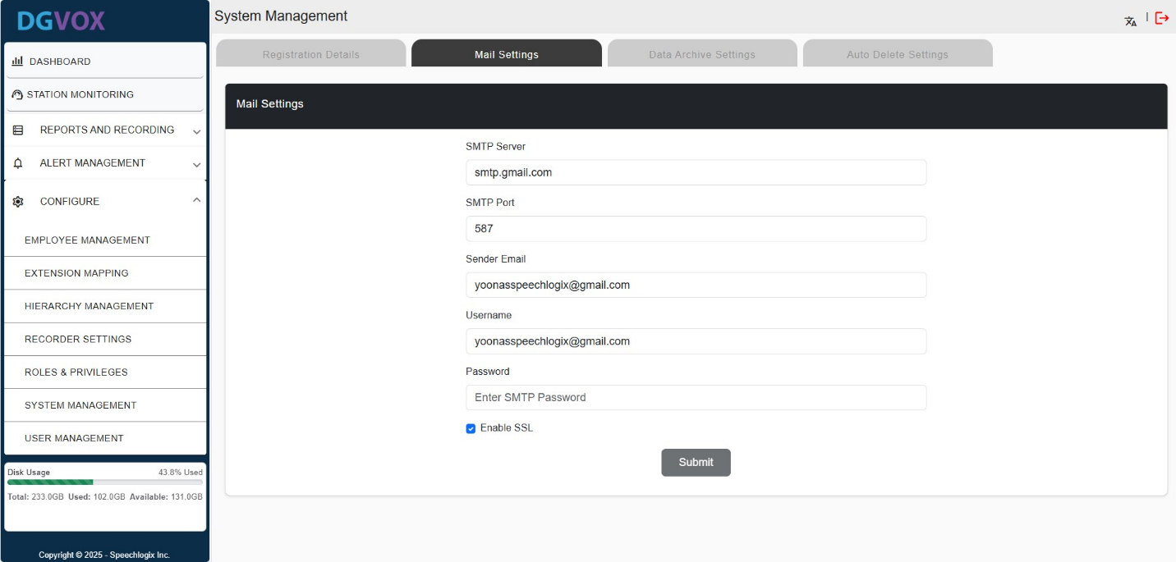

### **6.6.3. Data Archive Settings**

The **Data Archive Settings** menu is used to back up or move recorded data to an external system for long-term storage or reference. This feature helps ensure data is not lost and is easily retrievable in the future. Archiving can be configured to happen either **automatically** or **manually**, depending on system preferences.

Go to the **Configure** menu, select **System** **Management**, and click the "**Data Archive Settings**" tab to open a form.

|  |  |
| --- | --- |
| **Field** | **Description** |
| **Username** | This is the login ID for the destination system where archived data will be stored. |
| **Password** | The corresponding password for the destination system. |
| **Archive Directory** | Specifies the location (path) on the external system where the archived data should be saved. |
| **Local Mount Directory** | The local directory on the current system that contains the data intended for archiving. |
| **Audio** **Encryption** | Enable the checkbox to ensure secure transfer of files during the archive process. |

Once the necessary details are entered, you can click the “**Mount”** button to establish the connection and proceed with the archiving process by clicking **“Next”** Button.

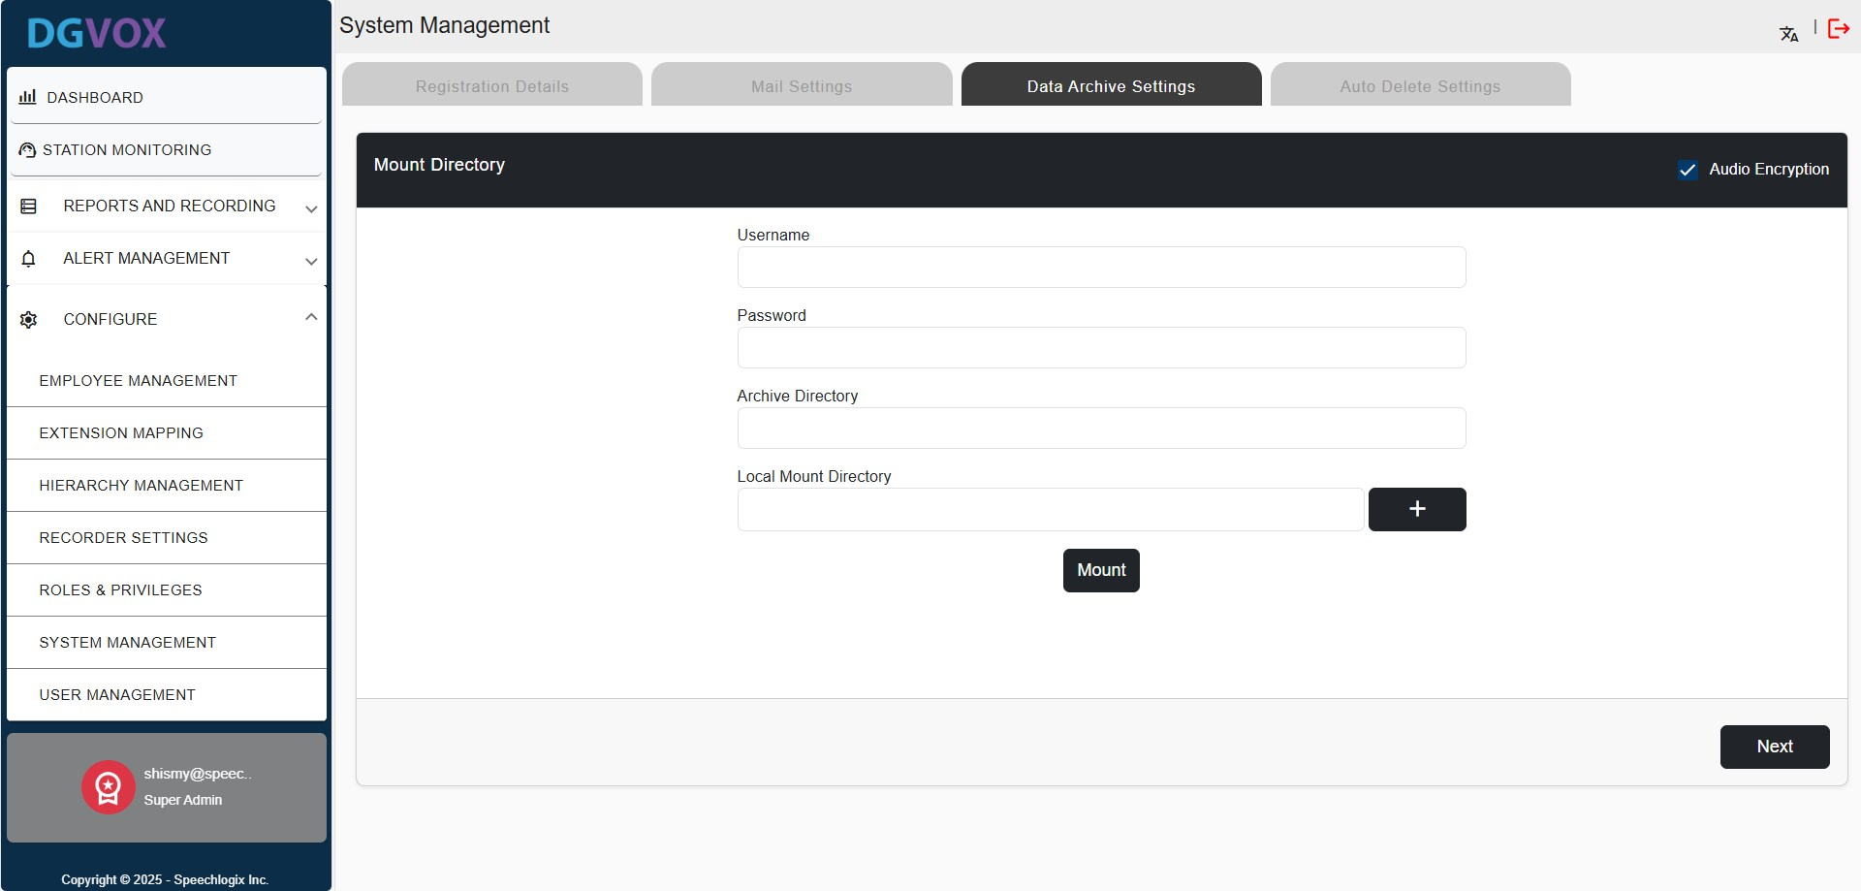

Here, you can select your preferred method for archiving data - **Automatic** or **Manual**.

* If you choose the **Auto** option:
  + Select the desired **schedule frequency** from the dropdown menu: **Daily**, **Weekly**, or **Monthly**.
  + Specify the **time** at which the archive should be triggered.
  + After entering the required details, click the **Archive** button to save and activate the schedule.

The system will then automatically archive data according to the configured settings.

* If you select the **Manual** option:
  + Specify the file or directory path where the data should be archived.
  + Once all necessary details are entered, click the **Archive** button to initiate the process.

The system will then archive the data immediately based on the provided input.

The **archive history** is displayed on the far right side of the screen, showing a record of previously scheduled or completed archive jobs.

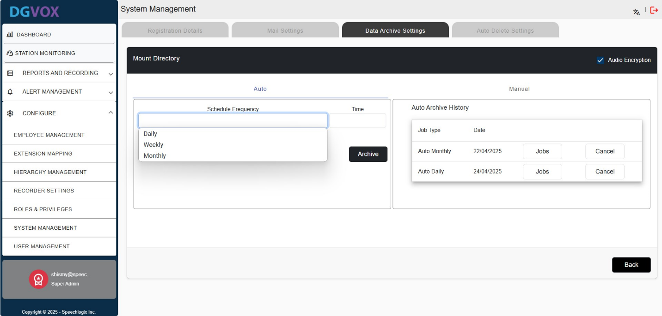

### **6.6.4. Auto-Delete Settings**

The Auto Delete Settings menu allows you to automate the deletion of old or unused data when storage usage reaches a critical level. This helps ensure the system maintains enough free space to operate efficiently without manual intervention.

Go to the **Configure** menu, select **System** **Management**, and click the "**Auto Delete Settings**" tab to open a form.

|  |  |
| --- | --- |
| **Field** | **Description** |
| **Auto Delete Type** | This dropdown lets you select the method used to trigger auto-deletion.  If the type is set to **Threshold**, meaning the system will monitor storage usage and act when it exceeds the defined limits.  If the type is set to **Time Based**, meaning data will be deleted after a specified duration, regardless of storage usage. |
| **Storage Threshold Limits (%)** | These fields define the storage usage percentage that will trigger the auto-delete process:  **Cut**-**off** **Threshold**: Specifies the lower storage limit (e.g., 90%). When disk usage reaches or exceeds this value, the system starts evaluating files for deletion.  **Upper** **Threshold**: Sets the maximum allowable disk usage (e.g., 91%). If this limit is hit, the system will automatically begin deleting older or less critical data to bring usage back below the threshold. |
| **Retention Period** | Select the duration for which data should be retained before being automatically deleted. Once the selected time period elapses, the system will remove data older than that. |

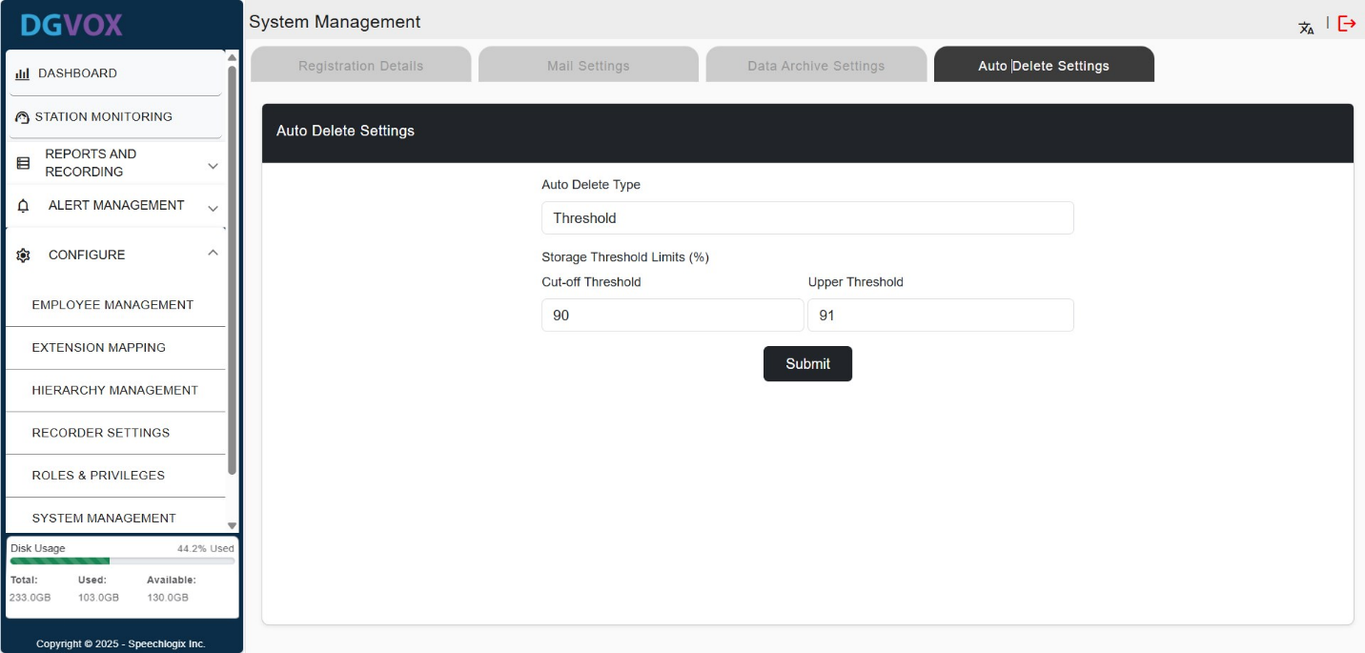

## **6.7. User Management**

The **User Management** menu allows administrators to manage system-level user access, including assigning extensions, user groups, and maintaining contact information.

Go to the **Configure** menu, select **User** **Management**, and click on the "**Add** **User**" button to open a form for manually adding a new user.

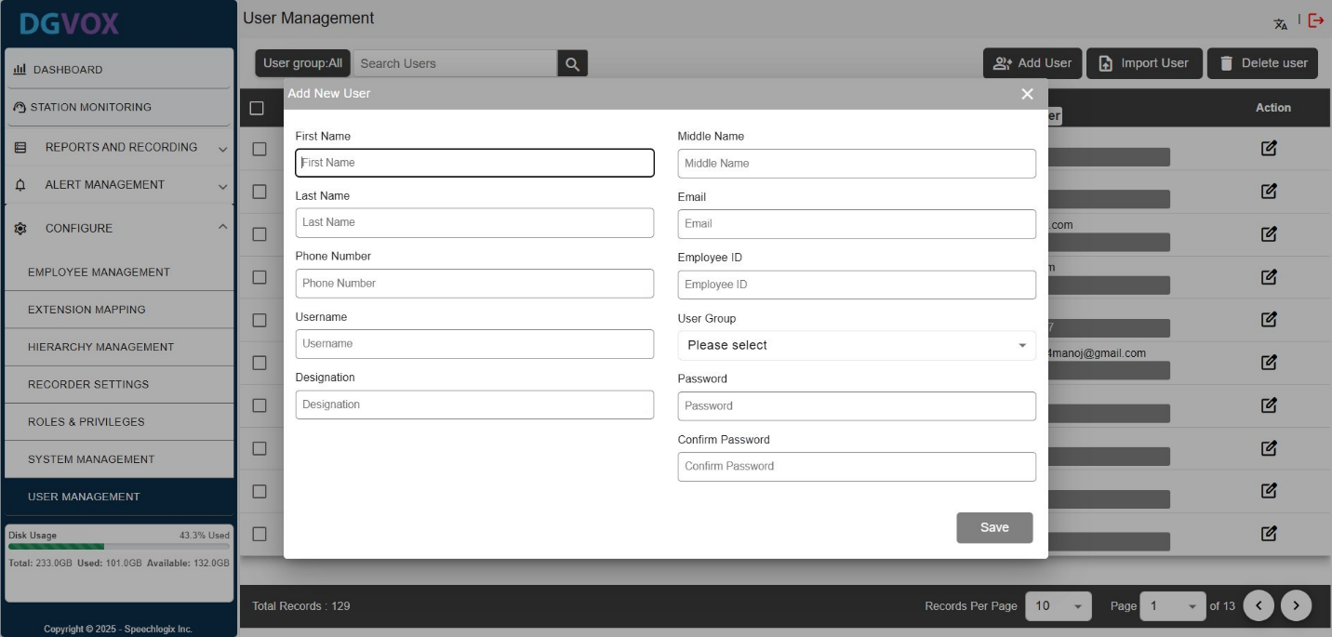

|  |  |
| --- | --- |
| **Fields** | **Description** |
| **First Name** | Enter the user’s first name. This field is mandatory. |
| **Middle Name** | Enter the user’s middle name, if applicable. |
| **Last Name** | Enter the user’s last name or surname. |
| **Email** | Enter a valid email address for the user. Required for notifications. |
| **Phone Number** | Enter the user’s contact number. |
| **Employee ID** | Unique identifier for the employee; must be at least 4 characters long. |
| **Username** | Used for login purposes; must be unique in the system. |
| **User Group** | Assigns the user to a specific group or department.  To create a user group, refer to the ‘*User Group Filter*’ section. |
| **Designation** | Specifies the user's job title or role (e.g., Analyst, Manager). |
| **Password** | Used to secure the account; must meet security policies. |
| **Confirm Password** | Must match the password entered above to verify accuracy. |

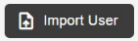**To add multiple users simultaneously**, click the **"Import User"** button. This will open a popup window where you can choose the target **user group** for the import. Download the available template, enter the necessary employee information into the file, save it, and upload the completed template to finalize the import process.

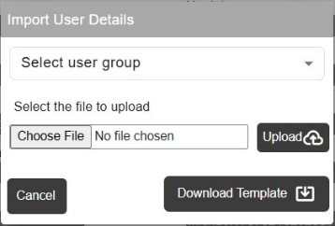

Once the information is saved, it will appear on the screen as shown below, with options available to edit or delete the entry.

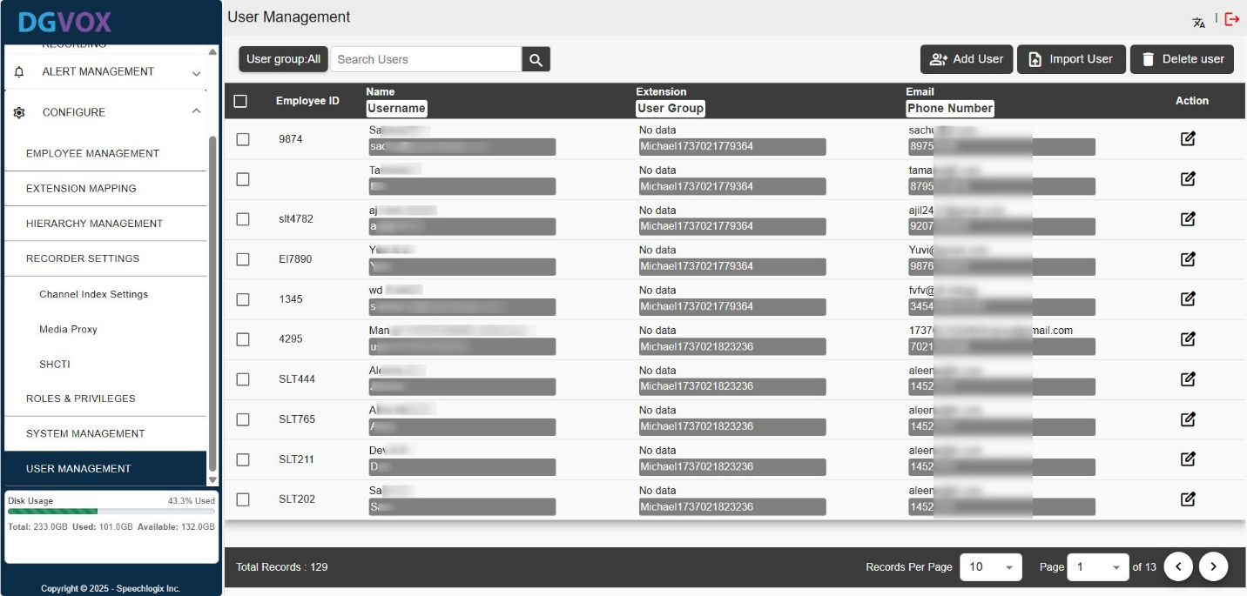To ***modify a user's details***, click the edit icon next to the respective row. A popup window will appear displaying the current information. Make the necessary changes and click the "**Update**" button to save them.

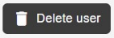

To ***remove details***, select the checkboxes next to the desired rows, then click the "Delete" button. A confirmation prompt will appear, confirm the action to permanently delete the selected records from the list.

**Search Employees**: A search bar that allows users to quickly find employees by name or email.

**Report Button**: Exports or generates a report of employee data, useful for audits or backups.

### **6.7.1. Adding User Groups**

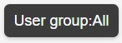**User Group Filter**: A Dropdown that filters users by group, enabling focused views.

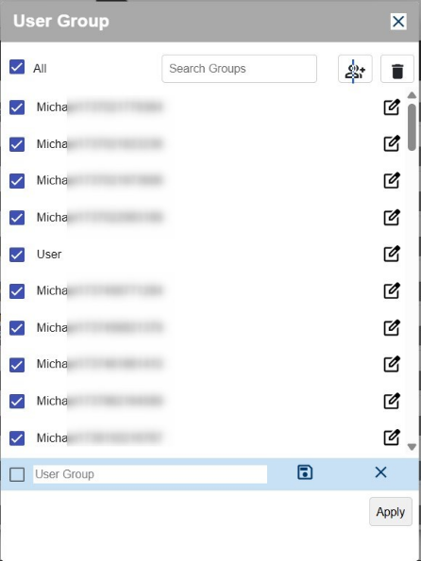

Click the **User Group Filter** button to open a popup for managing and assigning user groups. This popup displays a list of existing user groups, each with a checkbox for selecting or deselecting them.

You can filter the list using the "**Search Groups**" field by typing relevant keywords.

To ***create a new user group***, click the ‘*Add User Group’* icon - this reveals a text input field at the bottom where you can enter the group name and click the save icon.

To ***remove user groups***, select the desired ones using the checkboxes and click the ‘*Delete*’ icon.

# **7. Conclusion**

The DGVOX user guide is designed to help administrators and users effectively configure, manage, and utilize the system’s powerful call recording and monitoring features.

By following the configurations outlined in this guide, users can ensure accurate data capture, streamline operations, and maintain high-quality communication records.